Guided Notes
Chapter 5
Polynomials and Polynomial Functions
Answer Key

Unit Essential Questions

What does the degree of a polynomial tell you about its related polynomial function?

For a polynomial function, how are factors, zeros and x-intercepts related?

For a polynomial equation, how are factors and roots related?

Section 5.1: Polynomial Functions

Students will be able to classify polynomials

Students will be able to graph polynomial functions and describe end behavior

Warm Up
Simplify each expression by combining like terms.
- 3x + 5x – 7x
x
- –8xy² – 2x²y + 5x²y
-8xy² + 3x²y
- –4x + 7x² + x
7x² – 3x

Key Concepts
Monomial – a real number, a variable, or a product of a real number and one or more variables with whole number exponents
Degree of a Monomial – the exponent of the variable
Polynomial – a monomial or the sum of monomials
Degree of a Polynomial – the largest degree of any term of the polynomial

Standard Form of a Polynomial – arranges the terms by degree in a descending numerical order P(x) = a_{n}x^{n} + a_{n-1}x^{n-1} + ... + a₁x + a₀ where n is a nonnegative integer and a_{n},….,a₀ are real numbers.

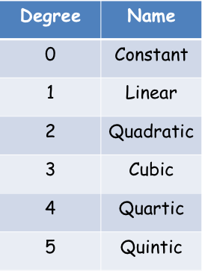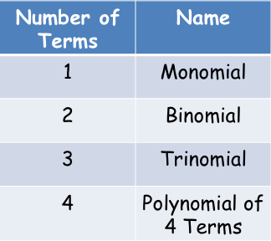

Examples
- Write each polynomial in standard form. Then classify it by degree and by number of terms.
- 9 + x³

x³ + 9; Cubic Binomial

- 7x³ – 2x² – 3x⁴

– 3x⁴ + 7x³ – 2x² ; Quartic Trinomial

- Write in standard form and classify by its degree and number of terms.

- (x² - 3x + 4)(-5x² + 8x + 3)

-5x⁴ + 23x³ - 41x² + 23x + 12; Quartic Polynomial of 5 terms

- (4y² + 9y + 7) - (y² - 5y + 6)

3y² + 14y + 1; Quadratic Trinomial

- (x² + 4)(x + 2)²

x⁴ + 4x³ + 8x² + 16x +16; Quartic Polynomial of 5 terms

Key Concepts
Ending Behavior – direction of the graph to the far left and to the far right.

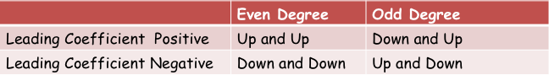

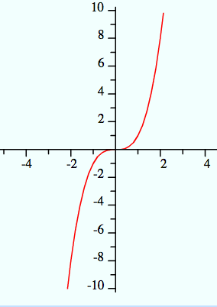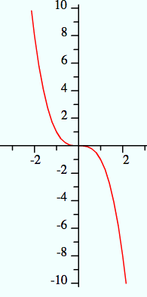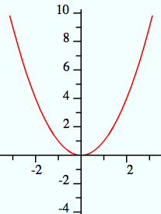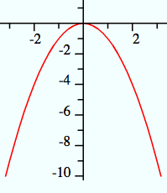
Down and Up Up and Down Up and Up Down and Down

Examples
- What is the ending behavior of the graph? Check using graphing calculator.

- y = 4x³ – 3x

down and up

- y = -2x⁴ +8x³ – 8x² + 2

down and down

Section 5.2 Part 1: Polynomials, Linear Factors, and Zeros
Students will be able to analyze the factored form of a polynomial
Students will be able to write a polynomial function from its zeros
Warm Up
Factor each quadratic expression.
- x² + 7x + 12

(x + 3) ( x + 4)

- x² + 8x – 20

(x + 10) (x – 2)

- x² – 14x + 24

(x – 12) (x – 2)

Examples
- Write 3x³ – 18x² + 24x in factored form.

3x(x – 4)(x – 2)

Key Concepts
The following are equivalent statements about a real number b and a polynomial
P(x) = a_{n}x^{n} + a_{n-1}x^{n-1} + ... + a₁x + a₀
- x – b is a linear factor of the polynomial P(x)
- b is a zero of the polynomial function y = f(x)
- b is a root (or solution) of the polynomial equation f(x) = 0
- b is an x-intercept of the graph y = f(x)

Steps to Graphing a Polynomial Function
- Use the Zero-Product Property to find the zeros.
- Find points between the zeros.
- Determine ending behavior.
- Use zeros, additional points, and ending behavior to sketch the graph.

Examples
- Find the zeros of y = (x + 1)(x – 1)(x + 3). Then graph the function.

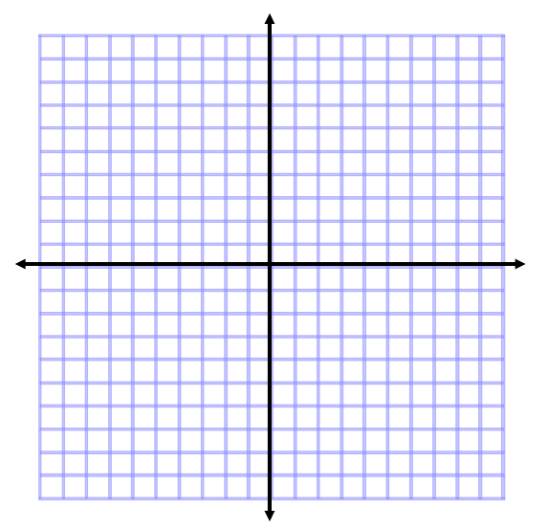
Zeros of the function are -3,-1, 1

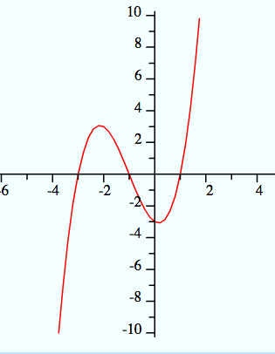

Key Concepts

Factor Theorem
The expression x – a is a factor of a if the value a is a zero of the related polynomial function.

Examples
- Write a polynomial in standard form with zeros at 2, –3, and 0.

f(x) = x³ +x² - 6x

Section 5.2 Part 2: Polynomials, Linear Factors, and Zeros
Students will be able to analyze the factored form of a polynomial
Students will be able to identify relative maximums and minimums
Warm Up

- What are the zeros of f(x) = (x – 2)(x – 2)(x + 1)?
2, 2, -1

- Suppose someone listed the zeros as 2 and -1. Why might someone think this is a quadratic function?
Answers vary

Key Concepts
Multiple Zero - repeated zero
Multiplicity - the number of times the zero occurs

Example
- What are the zeros of ƒ(x) = x⁵ – 6x⁴ + 9x³?What are their multiplicities? How does the graph behave at these zeros?

Zeros are 0 and 3.
0 has a multiplicity of 3 and 3 has a multiplicity of 2.
The graph looks like a parabola at x = 3 and close to linear at x = 0

Key Concepts
Relative maximum - the greatest y-value of the points in a region of graph
Relative minimum - the least y-value among nearby points on a graph

Example
- What are the relative maximum and minimum of ƒ(x) = -4x³ + 12x² + 4x – 12.
Relative Maximum: (2.15, 12.32)
Relative Minimum: (-0.15, -12.32)

Section 5.3 Part 1: Solving Polynomial Equations
Students will be able to factor polynomial expressions
Warm Up
Factor.
- 6x² + 12x
6x(x + 2)

- 8x² + 10x – 3
(4x – 1)(2x + 3)

- x² – 81
(x + 9)(x – 9)

Key Concepts

Factoring by Grouping (4 terms)
ax + ay + bx + by = a(x + y) + b(x + y) =(a + b)(x + y)

Sum of Cubes
a³ + b³ = (a + b)(a² - ab +b²)

Difference of Cubes
a³ – b³ = (a – b)(a² + ab + b²)

Examples
- Factor x³ + 2x² – 3x – 6.

(x² – 3)(x + 2)

- Factor x³ – 8.

(x – 2)(x² + 2x + 4)

- Factor x³ + 27.

(x + 3)(x² – 3x + 9)

Section 5.3 Part 2: Solving Polynomial Equations
Students will be able to solve polynomial equations by factoring
Warm Up
Factor.
- x² + 10x + 25

(x + 5)²

- x³ + 2x² – 4x – 8

(x + 2)²(x – 2)

- x³ - 64

(x – 4)(x² + 4x + 16)

Key Concepts
Steps to solve a polynomial equation by factoring:
- Write the equation in the form P(x) = 0
- Factor P(x)
- Use the Zero-Product Property to find the roots

Examples
- What are the real and imaginary solutions to 2x³ - 5x² = 3x?

0, -1/2, 3

- What are the real and imaginary solutions to x⁴ -3x² = 4?

-2, 2, i, -i

- What are the real and imaginary solutions to x³ = 1?

1, -½ + i√3/2, -½ - i√3/2

Section 5.4 Part 1: Dividing Polynomials
Students will be able to divide polynomials using long division
Warm Up
Divide using long division
- 531 ÷ 3 2. 672 ÷ 21

177 32

Key Concepts

The Divisor Algorithm
You can divide polynomial P(x) by polynomial D(x) to get the quotient Q(x) and a remainder R(x).
If R(x) = 0, then D(x) and Q(x) are factors of P(x).

Steps to Long Division of Polynomials
- Put each polynomial in standard form with zero coefficients where appropriate
- Divide, multiply, subtract and repeat until the degree of the remainder is less than the divisor.

Examples
- Divide x² + 2x – 30 by x – 5.

x + 7, R: 5

- Determine whether x + 2 is a factor of the polynomial x² + 10x + 16.

Yes, x + 2 is a factor of x² + 10x + 16

Section 5.4 Part 2: Dividing Polynomials
Students will be able to divide polynomials using synthetic division
Warm Up
Evaluate for the given variables.

12

Key Concepts
Synthetic Division – simplifies long division for dividing by a linear expression x – a.

Steps for Synthetic Division
- Write coefficients (including zeros) of the polynomial in standard form. For the divisor, use the value for x such that x – a = 0 (use a).
- Bring down the first coefficient.
- Multiply the divisor and add it to the next coefficient.
- Continue through the last coefficient.
Example
- Use synthetic division to divide 5x³ – 6x² + 4x – 1 by x - 3.

5x² + 9x + 31, R 92

Key Concepts

Remainder Theorem
If you divide a polynomial P(x) by x – a, then the remainder is P(a).

Example
- Given that P(x) = x⁵ – 3x⁴ – 28x³ + 5x + 20, what is P(-4)?

P(-4) = 0

Section 5.5 Part 1: Theorems About Roots of Polynomial Equations
Students will be able to solve equations using the Rational Root Theorem
Warm Up
List all the factors of each number.
- 12
1, 2, 3, 4, 6, 12

- 24
1, 2, 3, 4, 6, 8, 12, 24

3. 44
1, 2, 4, 11, 22, 44

Key Concepts

Rational Root Theorem
Let P(x) = a_{n}x^{n} + a_{n-1}x^{n-1} + ... + a₁x + a₀ be a polynomial with integer coefficients. Then there are a limited number of possible roots of P(x) = 0:
- Integer roots must be factors of a₀.
- Rational roots must have reduced form p/q where p is an integer factor of a_{o} and q is an integer factor of a_{n}.

Steps to Finding Rational Roots
- List the possible rational roots using the Rational Root Theorem.
- Test each possible rational root (REMINDER – you could also use synthetic division to evaluate).
Examples
- Find the rational roots of 3x³ – x² – 15x + 5 = 0.

1/3

- Find the rational roots of 2x³ – x² + 2x + 5 = 0.

-1

Section 5.5 Part 2: Theorems About Roots of Polynomial Equations
Students will be able to use the conjugate root theorem and Decartes’ Rule of Signs
Warm Up
Multiply.
- (-4i)(6i)

24

- (2 + i)(2 – i)

5

- (1 + √3)(1 - √3)

-2

Key Concepts

Conjugate Root Theorem
If P(x) is a polynomial with rational coefficients, then the irrational roots of P(x) occur in pairs. If a - √b is an irrational root, then a + √b is also a root.

Imaginary Root Theorem
If the imaginary number a + bi is a root of a polynomial equation with real coefficients, then the conjugate a – bi also is a root.

Examples
- A cubic polynomial P(x) has real coefficients. If 2 – 3i and ¾ are two roots of P(x), what is an additional root?

2 + 3i

- A quartic polynomial P(x) has real coefficients. If √3 and 6 – 2i are two roots of P(x), what are the other two roots?

6 + 2i and -√3

- Find a third degree polynomial with rational coefficients that has roots –2, and 2 – i.

P(x) = x³ – 2x² – 3x + 10

Key Concepts

Decartes’ Rule of Signs
Let P(x) be a polynomial with real coefficients written in standard form.
- The number of positive real roots of P(x) = 0 is either equal to the number of sign changes between consecutive coefficients of P(x) or is less than that by an even number.
- The number of negative real roots of P(x) = 0 is either equal to the number of sign changes between consecutive coefficients of P(-x) or is less than that by an even number.

Examples
- What does Decartes’ Rule of Signs tell you about the real roots of x³ - x² + 1 = 0?

Since there are two sign changes, there are either 0 or 2 positive real roots.
Since there is one sign change, there is one negative real root.

Section 5.6: The Fundamental Theorem of Algebra
Students will be able to use the Fundamental Theorem of Algebra to solve polynomial equations with complex solutions
Warm Up
Solve x² + 3x – 7 = 0.

-3/2 + √37/2, -3/2 - √37/2

Key Concepts

The Fundamental Theorem of Algebra
If P(x) is a polynomial of degree n ≥ 1, the P(x) = 0 has exactly n roots, including multiple and complex roots.

Steps to find ALL roots of a polynomial equation
- Put polynomial in standard form and find possible rational roots.
- Find a rational root.
- Use synthetic division to find another factor.
- Repeat until the quotient is factorable or a quadratic.
- Solve.

Examples
- Find the roots of 5x³ – 24x² + 41x – 20 = 0.

2 + i, 2 – i, 4/5

- Find the roots of x⁴ + x³ – 7x² - 9x – 18 = 0.

3, -3, -1/2 + i√7/2, -1/2 - i√7/2

