Guided Notes

Chapter 1  
Expression, Equations, and Inequalities

Answer Key



**Unit Essential Questions**

How do variables help you model real-world situations?

How can you use properties of real numbers to simplify algebraic expressions?

How do you solve an equation or inequality?

**Section 1.1: Patterns and Expressions**

**Students will be able to identify and describe patterns**

**Warm Up**



0 107/10 72 -3/4

**Key Concepts**

Variable - a symbol, usually a letter, that represents one or more numbers

Numerical Expression - a mathematical phrase that contains numbers and operation symbols

Algebraic Expression - a mathematical phrase that contains one or more variables

**Examples**

1. Describe each pattern using words. Draw the next figure in the pattern.
   1. 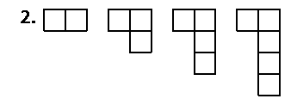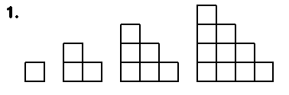 b)

The bottom row increases by one One square is added to the right bottom

1. 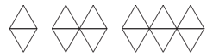 These figures are made with toothpicks.
   1. How many toothpicks are in the 20th figure? Use a table of values with a process column to justify your answer.

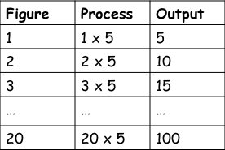

The 20th figure has 100 toothpicks.

* 1. What expression describes the number of toothpicks in the *n*th figure? 5n

1. Identify a pattern by making a table of the inputs and outputs. Include a process column.
   1. 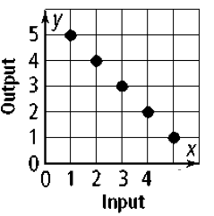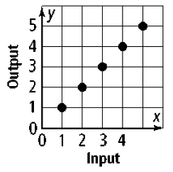 b)

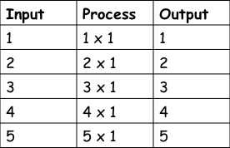 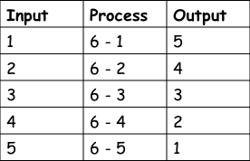

1. Identify a pattern and find the next three numbers in the pattern.
   1. 2, 4, 8, 16, …

multiply by 2; 32, 64, 128

* 1. 4, 8, 12, 16, …

add 4; 20, 24, 28

* 1. 5, 25, 125, 625, …

multiply by 5; 3125, 15625, 78125

**Section 1.2: Properties of Real Numbers**

**Students will be able to graph and order real numbers.**

**Students will be able to identify properties of real numbers.**

**Warm Up**

Write each number as a percent.



50% 25% 33.3% 140% 172% 123%

**Key Concepts**

Subsets of the Real Numbers

|  |  |  |
| --- | --- | --- |
| Name | Description | Examples |
| Natural Numbers | {1, 2, 3, …}  *These are the counting numbers* | 4, 7, 15 |
| Whole Numbers | {0, 1, 2, 3, … }  *Add 0 to the natural numbers* | 0, 4, 7, 15 |
| Integers | {…, -2, -1, 0, 1, 2, 3, …}  *Add the negative natural numbers to the whole numbers* | -15, -7, -4, 0, 4, 7 |
| Rational Numbers | *These numbers can be expressed as an integer divided by a nonzero integer:*  *Rational numbers can be expressed as terminating or repeating decimals.* |  |
| Irrational Numbers | *This is the set of numbers whose decimal representations are neither terminating nor repeating. Irrational numbers cannot be expressed as a quotient of integers.* |  |

Real Numbers

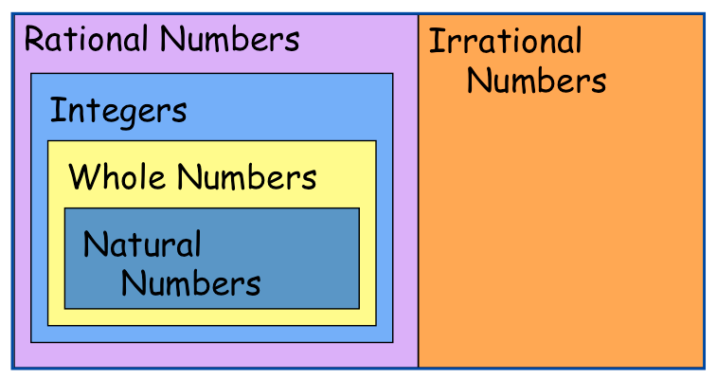

**Examples**

1. Classify and graph each number on a number line.
2. 3 b) c)



natural, whole, integer, rational rational irrational

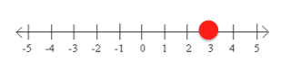 Macintosh HD:Users:tdeleon:Desktop:Screen Shot 2013-05-08 at 1.15.00 PM.png Macintosh HD:Users:tdeleon:Desktop:Screen Shot 2013-02-28 at 9.52.51 PM.png

1. Compare the two numbers. Use < and >.

a) -5, -8 b) 1/3, 1.333 c) 3,√3

-5 > -8 1/3 > 1.333 3 > √3

**Key Concepts**

Let a, b, and c be real numbers.

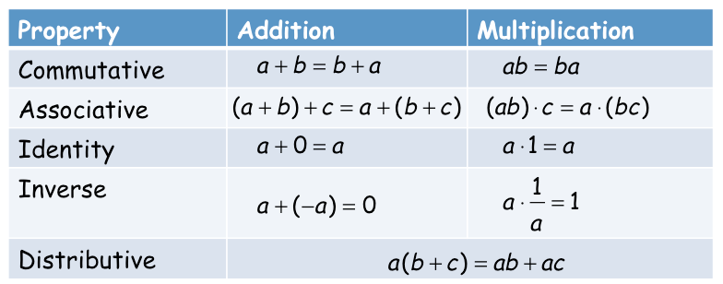

Opposite - (additive inverse) the opposite of any number *a* is *-a.*

Reciprocal - (multiplicative inverse) the reciprocal of any nonzero number *a* is 1/*a*.

**Examples**

1. Name the property of real numbers illustrated by each equation**.**
2. *n* · 1 = *n*

Multiplicative Identity

1. *a* (*b* + *c*) = *ab* + *ac*

Distributive Property

1. 4 + 8 = 8 + 4

Commutative Property of Addition

1. 0 = *q* + (-*q*)

Additive Inverse

**Section 1.3: Algebraic Expressions**

**Students will be able to evaluate algebraic expressions**

**Students will be able to simplify algebraic expressions**

**Warm Up**

Use order of operations to simplify.



9/4 35/3



3/2 38

**Key Concepts**

Term - an expression that is a number, a variable, or the product of a number and one or more variables

Coefficient - the numerical factor of a term

Constant Term - a term with no variable

Like Terms - the same variables raised to the same power

**Examples**

1. Write an algebraic expression that models each word phrase.
   1. six less than a number *w*

*w* – 6

* 1. the product of 11 and the difference of 4 and a number *r*

11(4 – *r*)

1. Evaluate each expression for the given values of the variables.
   1. 6*c* + 5*d* - 4*c* - 3*d* + 3*c* - 6*d*; *c* = 4 and *d* = -2

28

* 1. 10*a* + 3*b* - 5*a* + 4*b* + 1*a* + 5*b*; *a* = -3 and *b* = 5

42

1. Simplify by combining like terms
   1. 4 + 3*t* - 2*t* b) 3 - 2(2*r* - 4)

*t* + 4 -4*r* + 11

1. 9*y* + 2*x* - 4*y* + *x* d) -(*j* - 3*j* + 8)

3*x* + 5*y* 2*j* – 8

1. Write an algebraic expression to model the situation.

You fill your car with gasoline at a service station for $2.75 per gallon. You pay with a $50 bill. How much change will you receive if you buy *g* gallons of gasoline? How much change will you receive if you buy 14 gallons?

$50 – 2.75*g* $11.50

**Section 1.4: Solving Equations**

**Students will be able to solve equations**

**Students will be able to solve problems by writing equations**

**Warm Up**

Simplify.



7*x* – 4



2*b* – 28 2*k –* 2*m*

**Key Concepts**

|  |  |
| --- | --- |
| **Property** | **Definition** |
| Reflexive | a = a |
| Symmetric | If a = b, then b = a |
| Transitive | If a = b and b = c, then a = c |
| Substitution | If a = b, then you can replace a with b and vise versa |
| Addition/ Subtraction | If a = b, then a + c = b + c and a - c = b - c |
| Multiplication/ Division | If a = b and c = 0, then ac = bc and a/c = b/c |

**Examples**

1. Solve each equation. Check your answers.

a) 18 - n = 10 b) 3.5y =14

*n* = 8 *y* = 4

c) 5 - w = 2w -1 d) -2s = 3s - 0

w = 2 s = 0

1. Solve each equation. Check your answers.

a) 2(x + 3) + 2(x + 4) = 24 b) 8z + 12 = 5z - 21

x = 5/2 z = -11

c) 7b - 6(11 - 2b) = 10 d) 10k - 7 = 2(13 - 5k)

b = 4 k = 33/20

**Key Concepts**

Identity - an equation that is true for every value of the variable.

Literal Equation - an equation that uses at least 2 letters as variables. You can solve for any variable “in terms of” the other variables.

**Examples**

1. Determine whether the equation is *sometimes, always,* or *never* true.

a) 3x - 5 = -2 b) 2x - 3 = 5 + 2x

Sometimes Never

c) 6x -3(2 + 2x) = -6

Always

1. Solve each formula for the indicated variable.



**Section 1.5 Part 1: Solving Inequalities**

**Students will be able to solve and graph inequalities**

**Warm Up**

State whether the inequality is true or false.

1) 5 < 12 2) 5 < -12 3) 5 ≥ 5

True False True

**Key Concepts**

Writing and graphing inequalities

|  |  |  |
| --- | --- | --- |
| x > 4 | *x* is greater than 4 | Macintosh HD:Users:tdeleon:Desktop:Screen Shot 2013-03-01 at 11.39.12 AM.png |
| x ≥ 4 | *x* is greater than or equal to 4 | Macintosh HD:Users:tdeleon:Desktop:Screen Shot 2013-03-01 at 11.39.22 AM.png |
| x < 4 | *x* is less than 4 | Macintosh HD:Users:tdeleon:Desktop:Screen Shot 2013-03-01 at 11.39.37 AM.png |
| x ≤ 4 | *x* is less than or equal to 4 | Macintosh HD:Users:tdeleon:Desktop:Screen Shot 2013-03-01 at 11.39.43 AM.png |

**Examples**

1. Write an inequality that represents the sentence.
2. The product of 12 and a number is less than 6.

12x < 6

1. The sum of a number and 2 is no less than the product of 9 and the same number.

x + 2 ≥ 9x

1. Solve each inequality. Graph the solution.

a) 3x - 8 > 1 b) 3v ≤ 5v + 18

*x* > 3 *v* ≥ *-*9

 

c) 7 – x ≥ 24 d) 2(y - 3) + 7 < 21

*x* ≤-17 *y < 10*

 **

1. Is the inequality *always*, *sometimes*, or *never* true?

a) - 2(3*x* + 1) > - 6x + 7 b) 5(2x - 3) - 7*x* ≤ 3*x* + 8

Never Always

c) 6(2*x* – 1) ≥ 3*x* + 12

Sometimes

**Section 1.5 Part 2: Solving Inequalities**

**Students will be able to write and solve compound inequalities**

**Warm Up**

You want to download some new songs on your MP3 player. Each song will use about 4.3 MB of space. You have 7.8 GB of 19.5 GB available on our MP3 player. At most, how many songs can you download? (1 GB = 1024 MB)

You can download 1857 songs

**Key Concepts**

Compound Inequalities - two inequalities joined with the word *and* or the word *or*

*AND* means that a solution makes BOTH inequalities true.

OR means that a solution makes EITHER inequality true.

**Examples**

1. Solve each compound inequality. Graph the solution.

a) 4r > -12 and 2r < 10 b) 5z ≥ -10 and 3z < 3

r > -3 and r < 5 *z* ≥ -2 and z< 1

Macintosh HD:Users:tdeleon:Desktop:Screen Shot 2013-03-01 at 12.14.02 PM.png Macintosh HD:Users:tdeleon:Desktop:Screen Shot 2013-03-01 at 12.14.06 PM.png

1. Solve each compound inequality. Graph the solution.

a) -2 < *x* + 1 < 4 b) 3 < 5*x* - 2 < 13

-3 *< r* < 3 1 *< x* < 3

Macintosh HD:Users:tdeleon:Desktop:Screen Shot 2013-03-01 at 12.30.14 PM.png Macintosh HD:Users:tdeleon:Desktop:Screen Shot 2013-05-08 at 1.25.46 PM.png

1. Solve each compound inequality. Graph the solution.

a) 3x < -6 or 7x > 35 b) 5p ≥ 10 or -2p > 10

x < -2 or x > 5 *p* ≥ 2 or *p* < -5

Macintosh HD:Users:tdeleon:Desktop:Screen Shot 2013-03-01 at 12.33.20 PM.png Macintosh HD:Users:tdeleon:Desktop:Screen Shot 2013-03-01 at 12.33.47 PM.png

**Section 1.6 Part 1: Absolute Value Equations and Inequalities**

**Students will be able to write an solve equations involving absolute value**

**Warm Up**

Solve each equation.



x = 25/4 x = 13/5

**Key Concepts**

Absolute Value - the distance from zero on the number line. Written |x|

Extraneous Solution - a solution derived from an original equation that is NOT a solution to the original equation.

**Steps to solve an absolute value equation**

1. Isolate the absolute value expression
2. Write as two equations (set expression in the absolute value to the positive and negative - absolute value sign goes away)
3. Solve for each equation
4. Check for extraneous solutions

**Examples**

1. Solve.Check your answers.



x = 3, x = -2

1. Solve. Check your answers.



x = 1, x = -5

1. Solve. Check your answers.



x = -1

**Section 1.6 Part 2: Absolute Value Equations and Inequalities**

**Students will be able to write and solve inequalities involving absolute value**

**Warm Up**

You are riding an elevator and decide to find out how far it travels in 10 minutes. You start at the third floor and record each trip. If each floor is 12ft, how far did the elevator travel?

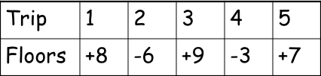

396 feet

**Key Concepts**

**Steps to solve an absolute value inequality**

1. Isolate the absolute value expression
2. Write as a compound inequality



1. Solve the inequalities

**Examples**

1. Solve the inequality. Graph the solution.



x < 3 and x > -2

Macintosh HD:Users:tdeleon:Desktop:Screen Shot 2013-03-01 at 1.12.40 PM.png

1. Solve the inequality. Graph the solution.



*x* ≥ 5 or *x* ≤ 0

Macintosh HD:Users:tdeleon:Desktop:Screen Shot 2013-03-01 at 1.12.17 PM.png