Guided Notes

Chapter 3

Linear Systems

Answer Key



**Unit Essential Questions**

How does representing functions graphically help you solve a system of equations?

How does writing equivalent equations help you solve a system of equations?

**Section 3.1: Solving Systems Using Tables and Graphs**

**Students will be able to solve linear systems using a graph**

**Warm Up**

Graph each equation. Use one coordinate plane for all 3 graphs.

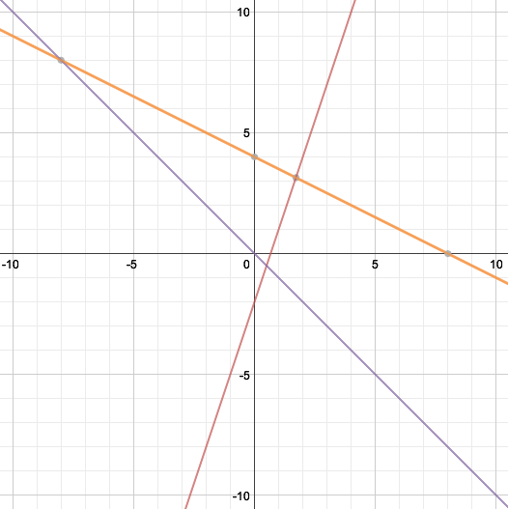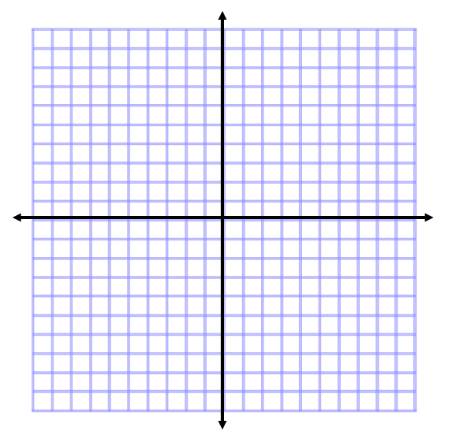

**Key Concepts**

**Systems of Equations**- a set of two or more equations that use the same variables.

**Linear System-** when the graph of each equation of a system is a line.

**Solution of a System** – a set of values for the variables that makes all the equations true.

**Examples**

1. Solve the system by graphing.

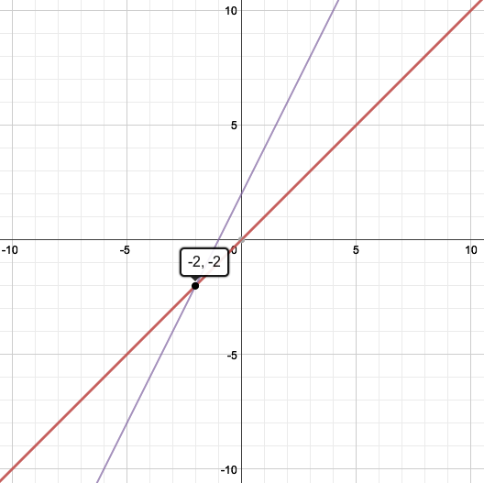



1. Solve the system by graphing.

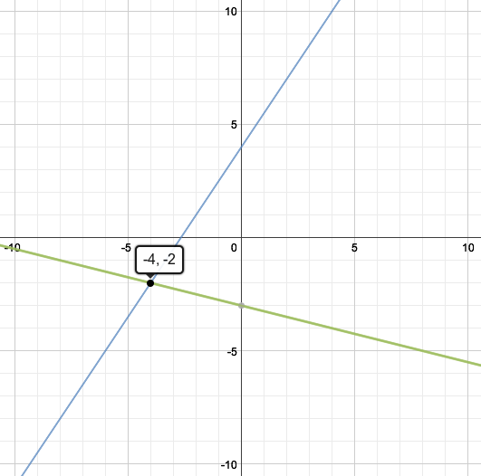





**Key Concepts**

**Independent system-** a system that has a unique solution. (Not every system has one)

* + - Intersecting lines
    - Different Slopes

**Dependent system-** a system that does not have a unique solution.

* + - Coinciding lines
    - Same Slope & Same Y-Intercept

**Inconsistent system-** a system with no solution.

* + - Parallel lines
    - Same Slope but Different Y-Intercepts

**Examples**

1. Classify the system without graphing.



Dependent

1. Classify the system without graphing.



Inconsistent

**Section 3.2 Part 1:Solving Systems Algebraically**

**Students will be able to solve linear systems using substitution**

**Warm Up**

Evaluate for a = 2 and b = -6

1. 2(7a – b) 2. a + b 3. b2

40 -4 36

**Key Concepts**

**Substitution** – means to plug in or replace a variable with an expression.

Steps for Solving Systems using Substitution:

1. Solve for one variable in one equation
2. Substitute that variable into the other equation.
3. Solve for a variable
4. Substitute the answer to solve for the other variable

**Examples**

1. Solve the system by substitution.





1. Solve the system by substitution.





**Section 3.2 Part 2:Solving Systems Algebraically**

**Students will be able to solve linear systems using elimination**

**Warm Up**

Find the additive inverse of each term.

1. 4 2. –*x* 3. 5*x* 4. 8*y*

-4 x -5x -8y

**Key Concepts**

**Elimination -** using the Addition Property of Equality, or use additive inverses to cancel a variable.

Steps for Solving Systems using Elimination:

1. Put each equation in standard form
2. Modify (if needed) one or both equations so that a variable will be eliminated
3. Add equations
4. Solve for a variable
5. Substitute the variable back into an equation to solve for the other variable

**Examples**

1. Use the elimination method to solve the system.





1. Use the elimination method to solve the system.





1. Use the elimination method to solve the system.





**Section 3.3: Systems of Inequalities**

**Students will be able to solve systems of linear inequalities**

**Warm Up**

Graph each Inequality.

 

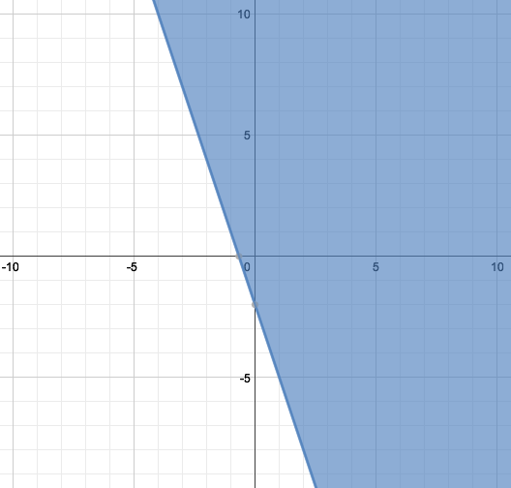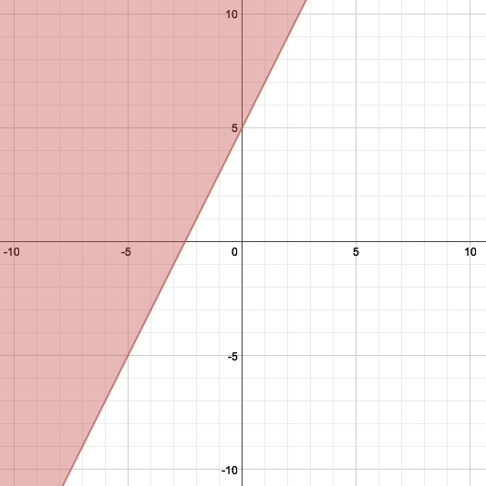

**Key Concepts**

You can solve a system of linear inequalities by **graphing**.

Steps to Solving Systems of Inequalities by Graphing:

1. First graph boundary lines and decide whether the boundary lines are included.
2. Then decide which side of the boundary lines to shade.
   * + If < or >, boundary not included; use dashed line.
     + If ≤ or ≥, boundary included; use solid line.
3. The solutions are any point where the shaded regions overlap.

**Examples**

1. Solve the system of inequalities by graphing.

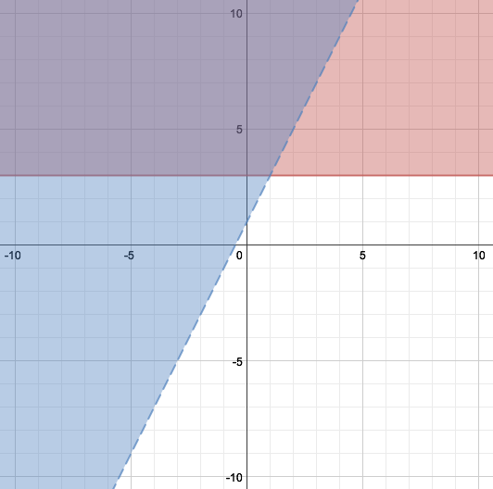

1. Solve the system of inequalities by graphing.

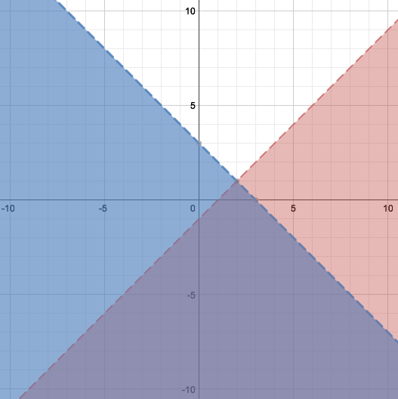 

**Section 3.5: Systems With Three Variables**

**Students will be able to solve systems in three variables**

**Warm Up**

Graph each ordered pair on the coordinate plane.

1. 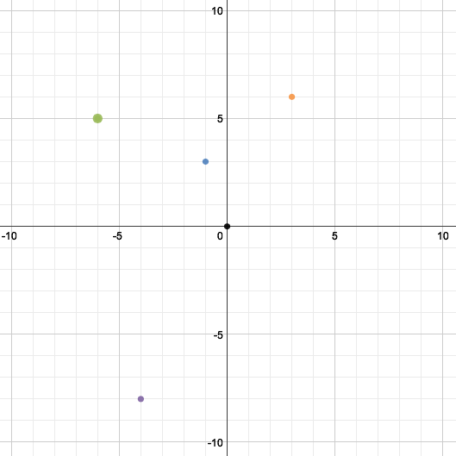(–4, –8)
2. (3, 6)
3. (0, 0)
4. (–1, 3)
5. (–6, 5)

**Key Concepts**

Steps for Solving Systems with Three Variables:

1. Write each equation in **standard form**.

2. Choose a **PAIR** of equations and eliminate one of the variables.

3. Choose a different pair of equations and eliminate the **SAME** variable.

4. Once steps 2 and 3 are complete, then use substitution or elimination method to solve for one variable.

5. Substitute the value you found in step 4 into one of the equations from step 4 and solve for the other variable.

6. Then substitute the two answers you found into the one of the original equations and solve for the remaining variable.

7. Put answer into **ordered triple**. (x, y, z).

**Examples**

1. Solve the system.





1. Solve the system.



