Guided Notes

Chapter 8  
Rational Functions

Answer Key



**Unit Essential Questions**

Are two quantities inversely proportional if an increase in one corresponds to a decrease in the other?

What kind of asymptotes are possible for a rational function?

Are a rational expression and its simplified form equivalent?

**Section 8.1: Inverse Variation**

**Students will be able to recognize and use inverse variation**

**Students will be able to use joint and other variations**

**Warm Up**

Suppose *y* varies directly with *x.*

1. Given that *x* = 2 when *y* = 4, find *y* when *x* = 5.

*y* = 10

2. Given that *x* = 1 when *y* = 5, find *y* when *x* = 3.

*y* = 15

3. Given that *x* = 10 when *y* = 3, find *y* when *x* = 4.

*y* = 1.2

**Key Concepts**

**Inverse Variation** - a function of the form y = k/x, x=k/y, or xy = k, where k ≠ 0.

**Examples**

1. Is the relationship between the variables a direct variation, an inverse variation, or neither? Write function a models for the direct and inverse variations.
   1. b) c)

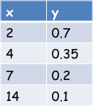 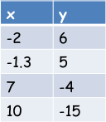 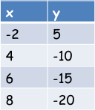

y varies inversely with x. Neither y varies directly with x.

y = 1.4/x y = -2.5x

1. Suppose that x and y vary inversely, and *x* = 2 when *y* = 8.
2. Write the function that models each inverse variation.

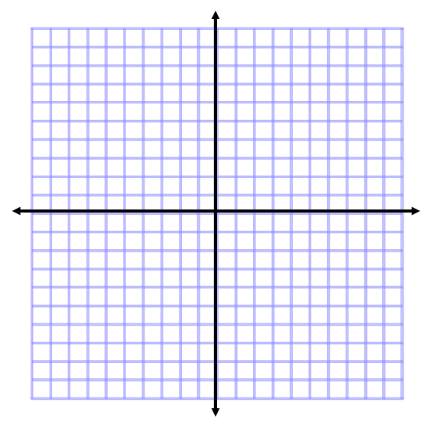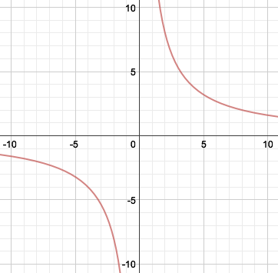 

1. Graph the function

c. Find *y* when *x* = 4.

y = 4

**Key Concepts**

**Combined Variation** – combines direct and inverse variations in more complicated relationships

**Joint Variation** – one quantity varies directly with 2 or more quantities

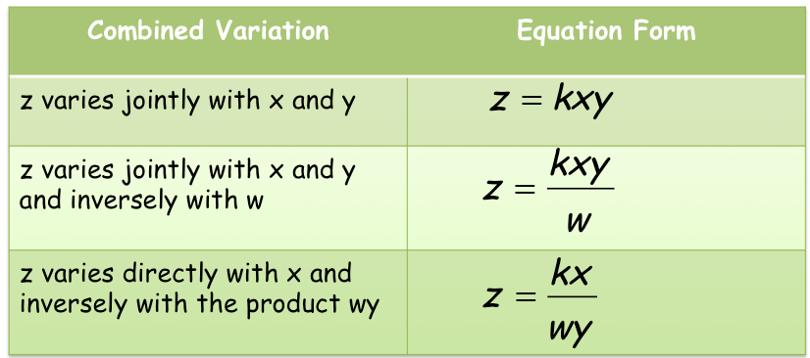

**Examples**

1. z varies directly with x and inversely with y. When x = 8 and y = 2, z = 12. Write the function that models the variation. Find z when x = 4 and y = 6.

 

1. z varies jointly with x and y. When x = 5 and y = 3, z = 60. Write the function that models the variation. Find z when x = 5 and y = 0.25.

 

**Section 8.2: The Reciprocal Function Family**

**Students will be able to graph reciprocal functions**

**Students will be able to graph translations of reciprocal functions**

**Warm Up**

Each of the following equations is a translation of *y* = |*x*|. Describe each translation.

1. *y* = |*x*| + 2 2. *y* = |*x* + 2|

Up 2 units Left 2 units

1. *y* = |*x*| – 3 4. *y* = |*x* – 3|

Down 3 units Right 3 units

5. *y* = |*x* + 4| – 5 6. *y* = |*x* – 10| + 7

Left 4 units, down 5 unit Right 10 units, up 7 units

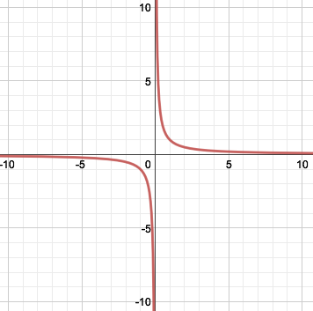**Examples**

1. Graph using a table of values.



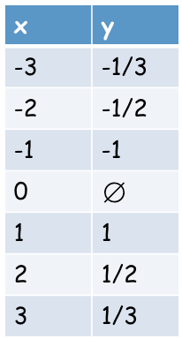

**Key Concepts**

**Reciprocal Function** – belongs to the family whose parent is 

**Branch** – each part of the graph of a reciprocal function.

The line **x = h** is a **vertical asymptote** and is a horizontal translation.

The line **y = k** is a **horizontal asymptote** and is a vertical translation.

**Examples**

1. 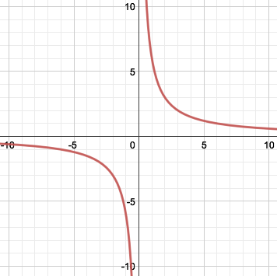Graph . Identify the x- and y- intercepts and the asymptotes of the graph. Also, state the domain and range.

The x-axis and y-axis are the asymptotes.

There is no x- or y- intercepts.

Domain: All real numbers except x = 0

Range: All real numbers except y = 0

1. Using a graphing calculator, graph the equations and  using the given values of a. How does the value of a change the graph?

a) a = 3

Stretched by 3

b) a = 0.4

Compressed by 0.4

c) a = -2

Stretched by 2

Reflected across the x-axis

**Key Concepts**

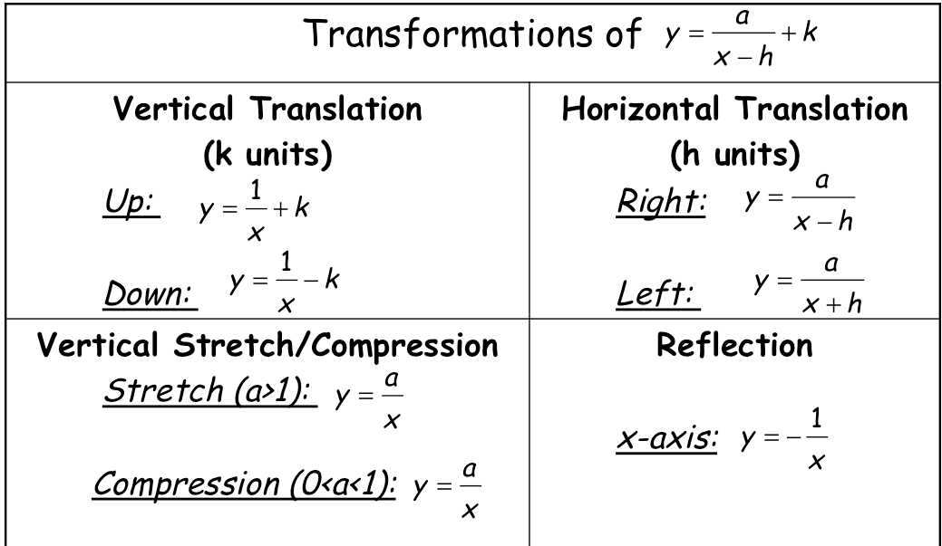

**Examples**

1. What is the graph of ? Identify the domain and range.

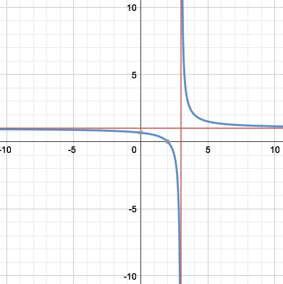

Domain is all real numbers except x = 3.

Range is all real numbers except y = 1.

1. Write an equation for the translation of  that has asymptotes at x = -1 and y = -7.



**Section 8.3: Rational Functions and Their Graphs**

**Students will be able to identify properties of rational functions**

**Students will be able to graph rational functions**

**Warm Up**

Factor.

1. *x*2 + 5*x* + 6 2*. x*2 – 6*x* + 8

(x + 3)(x + 2) (x – 4)(x – 2)

Factor and Solve.

3. *x*2 + *x* – 12 = 0 4. *x*2 – 9*x* + 18 = 0

x = -4, 3 x = 3, 6

**Key Concepts**

**Rational Function** – a function that you can write in the form 

**Continuous Graph** – a graph that has no breaks, jumps, or holes. (You can draw the graph without picking up you pencil)

**Discontinuous Graph** – a graph that has jumps, breaks or holes.

**Point of Discontinuity** – the point at which the graph is not continuous (x = a)

**Steps to Find Points of Discontinuity:**

1. Factor (if possible)
2. Set denominator = 0, solve for points of discontinuity (x = a)
3. If a point of discontinuity is a factor of the numerator, then the function has **Removable Discontinuity** or x = a is a **Hole**.
4. If a point of discontinuity is NOT a factor of the numerator, then the function has **Non-removable Discontinuity** or x = a is an **Asymptote**.

**Examples**

1. Use following rational function. 
   1. What is the domain of the rational function?

Domain is all real numbers except x = 4 and x = -3.

* 1. Identify the points of discontinuity. Are the points of discontinuity removable or non-removable?

There are two points of non-removable discontinuity at x = 4 and x = -3

* 1. What are the x- and y – intercepts?

(-4, 0) and (0, -1/3)

1. Use following rational function. 
   1. What is the domain of the rational function?

Domain is all real numbers.

* 1. Identify the points of discontinuity. Are the points of discontinuity removable or non-removable?

There are no discontinuities.

* 1. What are the x- and y – intercepts?

(0, 0)

1. Use following rational function. 
   1. What is the domain of the rational function?

Domain is all real numbers except x = -2.

* 1. Identify the points of discontinuity. Are the points of discontinuity removable or non-removable?

There is points of removable discontinuity at x = -2

* 1. What are the x- and y – intercepts?

(2, 0), (0, -2)

**Key Concepts**

**Vertical Asymptotes of Rational Functions** – the graph has a vertical asymptote at x = a if it has non-removable discontinuity at x = a.

**Examples**

1. What are the vertical asymptotes for the graph of
   1. 

x = -2 and x = 3 are vertical asymptotes.

* 1. 

x = -2 is a vertical asymptote.

There is a hole at x = -7.

**Key Concepts**

**Horizontal Asymptote of a Rational Function –** to find a horizontal asymptote, compare the degree of the numerator to the degree of the denominator.

Degree of numerator < degree of denominator:

Horizontal Asymptote: y=0

Degree of numerator = degree of denominator:

Horizontal Asymptote: y= ratio of leading coefficients

Degree of numerator > degree of denominator:

Horizontal Asymptote: No Horizontal Asymptote

**Examples**

1. What are the horizontal asymptote for the graph of
   1.  y = -2
   2.  y = 0
   3.  No Horizontal Asymptotes

**Key Concepts**

**Steps to Graphing a Rational Function:**

1. Find the ***horizontal asymptote*** (if there is one) using the rules for determining the horizontal asymptote of a rational function.
2. Factor both the numerator and denominator
3. Find any ***vertical asymptote(s)*** by setting the **denominator = 0** and solving for x.
4. Find the ***y-intercept*** (if there is one) by evaluating *f* (0)*.*
5. Find the ***x-intercepts*** (if there are any) by setting the **numerator = 0** and solving for x.
6. Find a few more points on the graph

**Examples**

1. What is the graph of the rational function ?

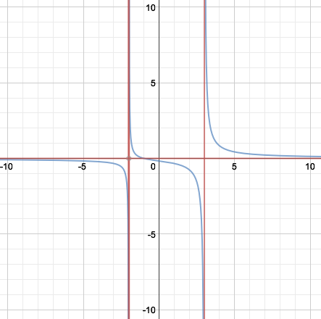

**Section 8.4: Rational Expressions**

**Students will be able to simplify expressions**

**Students will be able to multiply and divide rational expressions**

**Warm Up**

Factor.

1. 2x2 - 3x + 1 2. 4x2 – 9 3. 5x2 + 6x + 1

(2x – 1)(x – 1) (2x – 3)(2x + 3) (5x + 1)(x + 1)

**Key Concepts**

**Rational Expression** – the quotient of two polynomials.

**Simplest Form** – the numerator and denominator of a rational expression have no common factor

**Examples**

1. What is  in simplest form? State restrictions on the variable.



1. What is the product  in simplest form? State any restrictions on the variable.



1. What is the quotient  in simplest form? State any restrictions on the variable.



**Section 8.5 Part 1: Rational Expressions**

**Students will be able to add and subtract rational expressions**

**Warm Up**

**Add or Subtract.**

**1.**  2. 

 

**Key Concepts**

**Steps to Add or Subtract Rational Expressions:**

1. Find the LCD of the rational expressions.
2. Write each rational expression as an equivalent rational expression whose denominator is the LCD found in Step 1.
3. Add or subtract numerators, and write the result over the denominator.
4. Simplify resulting rational expression, if possible.

**Examples**

1. What is the least common multiple (LCM) of 2x2 - 8x + 8 and 15x2 - 60.



1. What is the sum of the two rational expressions in simplest form?





1. What is the difference of the two rational expressions in simplest form?





**Section 8.5 Part 2: Rational Expressions**

**Students will be able to add and subtract rational expressions**

**Warm Up**

Find the least common multiple of the two numbers.

1. 7, 21 2. 6, 10 3. 11, 17

21 30 187

**Key Concepts**

**Complex Fraction** - a fraction that has a fraction in its numerator or denominator or in both its numerator and denominator.

**Examples**

1. What is the simplest form of the complex fraction? 



1. What is the simplest form of the complex fraction? 



**Section 8.6: Solving Rational Equations**

**Students will be able to solve rational equations**

**Warm Up**

Solve.

1. x + 3 = 20 2. 2x - 7 = 13 3. x2 + 4x - 12=0

x = 17 x = 10 x = -6, 2

**Key Concepts**

**Rational Equation** – an equation that contains at least one rational expression.

**Steps to Solve a Rational Equation:**

1. Factor the denominators
2. Multiply each side by the LCD
3. Simplify
4. Solve
5. Check for extraneous solutions

**Examples**

1. What are the solutions of the rational equation? 

x = 1, -1

1. What are the solutions of the rational equation? 

No Solution