Guided Notes

Chapter 6  
Radical Functions and Rational Exponents

Answer Key



**Unit Essential Questions**

To simplify the *nth* root of an expression, what must be true about the expression?

When you square each side of an equation, is the resulting equation equivalent to the original?

How are functions and its inverse related?

**Section 6.0: Properties of Exponents**

**Students will be able to simplify expressions using properties of rational exponents**

**Warm Up**

Write each number as a square of a number.

1. 25 2. 0.09

52  0.32

Write each expression as a square of an expression.

3. *x*10 4. 169*x*6*y*12

(*x*5)2 (13*x*3*y*6)2

**Key Concepts**

**Properties of Exponents**

Assume that no denominator is equal to zero and *m* and *n* are integers

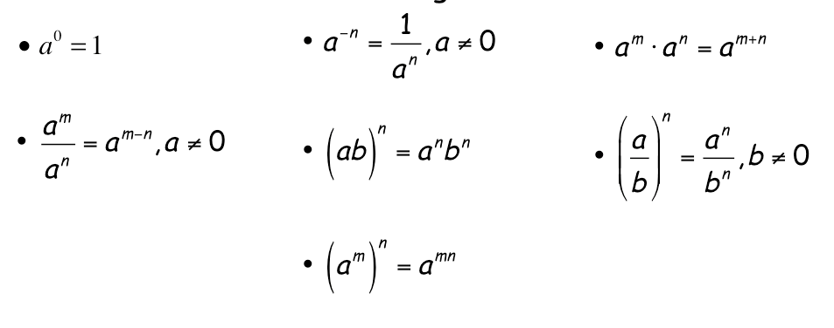

**Examples**

1. Simplify and rewrite each expression using only positive integers.

a.   b.  

1. Simplify and rewrite each expression using only positive integers.
2.   b.  
3. Simplify and rewrite each expression using only positive integers.

a.   b.  

**Section 6.1: Roots and Radical Expressions**

**Students will be able to find *n*th roots**

**Warm Up**

Simplify.

1.  2.  3. 

  

**Key Concepts**

***n*th Root -** For any real numbers *a* and *b*, and any positive integer *n*, if

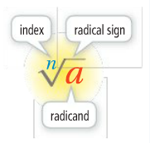 *an = b*, then *a* is an *n*th root of *b*.

* + If *n* is **odd**, there is **1** real *n*th root.
  + If *n* is **even**, there are **2** real *n*th roots.

**Radicand** - the number under the radical.

**Index** - the degree of the root.

**Principal Root** - the positive root when the number has two real roots.

**Examples**

1. Find all the real cube roots of:
2. 0.027 b. -125 c. 1/64

0.3 -5 1/4

1. Find all the fourth roots of:
2. 625 b. -0.0016 c. 81/625

 There is no real number 

with a fourth power of -0.0016

1. What is each principal real-number root?

a.  b.  c.  d. 

-3 0.3 There is no real number 3

with a fourth power of -16

**Key Concepts**

***n*th Roots of *n*th Powers**

For any real number *a*, 

**Examples**

1. Simplify each radical expression.

a.  b. 

 

**Section 6.2 Part 1: Multiplying Radical Expressions**

**Students will be able to multiply radical expressions**

**Warm Up**

Find each missing factor.

1. 150 = 52( 6 ) 2. 54 = ( 3 )3(2)
2. 48 = 42( 3 ) 4. *x*5 = ( x2 )2(*x*)

5. 3*a*3*b*4 = ( ab )3(3*b*) 6. 75*a*7*b*8 = ( 5a3b4 )2(3*a*)

**Key Concepts**

**Combining Radical Expressions: Product**



**Simplest Form** – where the radicand of has a perfect nth power among its factors that can be reduced to a simpler form as much as possible.

**Examples**

1. Can you simplify the product of the rational expressions? Explain.

a.  b.  c. 

Yes, 6 No, different Indexes Yes, -2

1. Simplify .



1. Multiply and Simplify .



**Section 6.2 Part 2: Dividing Radical Expressions**

**Students will be able to divide radical expressions**

**Warm Up**

Simplify.

1.  2. 

 

**Key Concepts**

**Combining Radical Expressions: Quotient**



**Rationalize the Denominator** – rewriting an expression so that there are no radicals in the denominator and no fractions in any radical expression.

**Examples**

1. Divide and simplify.

a.  b. 

-3 

1. Simplify .



1. Simplify .



**Section 6.3: Binomial Radical Expressions**

**Students will be able to add and subtract radical expressions**

**Warm Up**

Multiply.

1. (5*x* + 4)(3*x* – 2) 2. (*x* + 5)2

15x2 + 2x – 8 x2 + 10x + 25

**Key Concepts**

**Like Radicals** - radical expressions that have the same index and the same radicand.

**Rationalizing the Denominator of a Binomial** - multiply the numerator and denominator of the fraction by the conjugate of the denominator.

**Examples**

1. Add or subtract, if possible.

a.  b. 

 Different radicands, cannot subtract

1. Simplify .



1. Multiply .



1. Rationalize the denominator .



**Section 6.4 Part 1: Rational Exponents**

**Students will be able to use rational exponents**

**Warm Up**

Simplify.

1. 2–4 2. (3*x*)–2

 

1. (5*x*2*y*)–3 4. (2*a*–2*b*3)4

 

**Key Concepts**

**Rational Exponent**

If the nth root of *a* is a real number, *m* is an integer and *m/n* is in

lowest terms, then



**Examples**

1. Simplify.

a.  b.  c. 

4 7 5

1. Convert to radical form.

a.  b. 

 

1. Convert to exponential form.

a.  b. 

 

**Section 6.4 Part 2: Rational Exponents**

**Students will be able to use rational exponents**

**Warm Up**

Simplify.

1. (*x*2)3 2. (*pq*)5 3. (24)(25)

*x*6 *p*5*q*5 29 = 512

**Key Concepts**

All the properties of **integer** exponents also apply to **rational** exponents.

*(See properties of exponents for Section 6.0)*

**Examples**

1. Write  in simplest form.



1. Simplify each number.

a.  b. 25-2.5

9 

1. Write  in simplest form.



**Section 6.5 Part 1: Solving Square Root and Other Radical Equations**

**Students will be able to solve square root and other radical equations**

**Warm Up**

Solve by factoring.

1. *x*2 + *x* - 6= 02. *x*2 = 5*x* + 14

x = 2, -3 x = 7, -2

**Key Concepts**

**Radical Equation** - an equation that has a variable in a radicand or has a variable with a rational exponent.

Steps to Solve a Radical Equation

1. Isolate the radical.

2. Raise each side of the equation to a power equal to the index of the radical.

3. Solve the resulting equation. If the equation still has a radical then repeat steps 1 & 2.

4. Check your answer.

**Examples**

1. 

12

**Key Concepts**

Steps to Solve an Equation with a Rational Exponent

1. Isolate the expression with the rational exponent.
2. Raise each side of the equation to the reciprocal of the rational exponent.
   * + If the numerator or denominator are even, .
     + If the numerator and denominator are odd, .
3. Solve the resulting equation.
4. Check your answer.

**Examples**

1. Solve .

31

1. .

7, -9

**Section 6.5 Part 2: Solving Square Root and Other Radical Equations**

**Students will be able to solve square root and other radical equations with extraneous solutions**

**Warm Up**

Solve |3*x* + 2| - 5 = 4x. Check for extraneous solutions.

**x = -1**

**Key Concepts**

Note: It is possible to get extraneous solutions for square root and other radical equations. Therefore, **you must check all solutions**.

**Examples**

1. 

x = -1

1. 

x = 0, -4

**Section 6.6: Function Operations**

**Students will be able to add, subtract, multiply, and divide functions**

**Students will be able to find the composite of two functions**

**Warm Up**

Perform the indicated operation.

1. (x + 2x2 – 4) + (x2 – 3x + 9) 2. (x + 3)(x2 – 2) 3. (x – 1) – (5 + x)

3x2 – 2x +5 x3 + 3x2 - 2x – 6 -6

**Key Concepts**

**Function Operations**

Addition (f + g)(x) = f(x) + g(x)

Multiplication (f • g)(x) = f(x) • g(x)

Subtraction (f – g)(x) = f(x) – g(x)

Division (f/g)(x) = f(x)/g(x), g(x) ≠ 0

**Examples**

1. Let *f* (*x*) = –2*x* + 6 and *g* (*x*) = 5*x* – 7. Find (f + g)(x) and (ƒ – g)(x) and their domains.

(f + g)(x) = 3x -1 (ƒ – g)(x) = -7x +13

The domain of f is the set of all real numbers.

The domain of g is the set of all real number.

The domain of both f + g and f – g is the set all numbers common

to the domain both f and g, which is all real numbers.

1. Let *f*(*x*) = *x*2 + 1 and *g*(*x*) = *x*4 – 1. Find *f* • g and f/g and their domains.

*f* • g  f/g 

The domains of *f* and *g* are the set of real numbers, so the domain of *f* • *g* is also the set of real numbers.

The domain of f/g does not include 1 and –1 because *g*(1) and *g*(–1) = 0.

So the domain of f/g is all real numbers except 1 and -1.

**Key Concepts**

**Composite Function**

The composition of function *g* with function *f* is written as  and is defined as , where the domain of consists of the values in the domain of f such that *f* (a) is in the domain of *g*.

Steps to Evaluate a Composite Function

1. Read right to left.
2. Evaluate the inner function *f*(x) first.
3. Then use your answer as the input of the outer function *g*(x).

**Examples**

3. Let ƒ(x) = x3 and g(x) = x2 + 7. Find (g ° ƒ)(2).

71

4. A store offers a 20% discount on all items. You have a coupon worth $3.

* + 1. Use functions to model discounting an item by 20% and to model applying the coupon.

ƒ(x) = x – 0.2x = 0.8x   Cost with 20% discount.

g(x) = x – 3 Cost with a coupon for $3.

* + 1. Use a composition of your two functions to model how much you would pay for an item if the clerk applies the discount first and then the coupon.

0.8x – 3

* + 1. Use a composition of your two functions to model how much you would pay for an item if the clerk applies the coupon first and then the discount.

0.8x – 2.4

* + 1. How much more is any item if the clerk applies the coupon first?

Any item will cost $.60 more.

**Section 6.7 Part 1: Inverse Relations and Functions**

**Students will be able to find the inverse of a relation or function**

**Warm Up**

Solve for y.

1. x = 2y – 6 2. x = 2y2 + 5

 

**Key Concepts**

**Inverse relation** - “undoes” the relation and maps *b* back to *a*.

**Inverse Functions** - if you have *f* as a function then *f* -1 is its inverse.

**Examples**

1. Find the inverse of relation *m*.

*Macintosh HD:Users:tdeleon:Desktop:Screen Shot 2013-01-23 at 9.28.36 AM.png 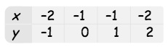*

1. What is the graph of the inverse of graph *m?*

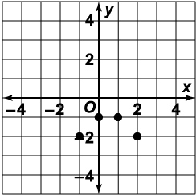 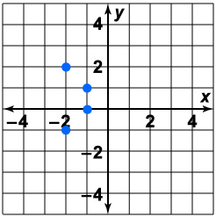

1. Find the inverse of *y* = *x*2 – 2.



1. Graph *y* = –*x*2 – 2 and its inverse.

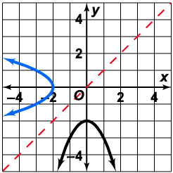

**Section 6.7 Part 2: Inverse Relations and Functions**

**Students will be able to find the inverse of a relation or function**

**Warm Up**

Graph on the same coordinate plane.

1.  2. 

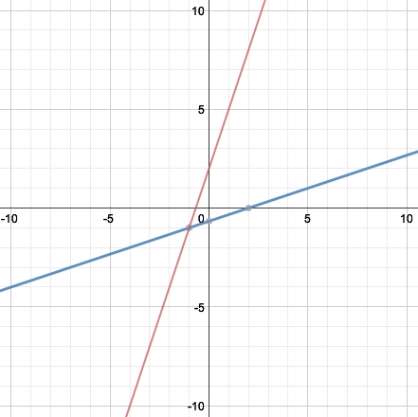 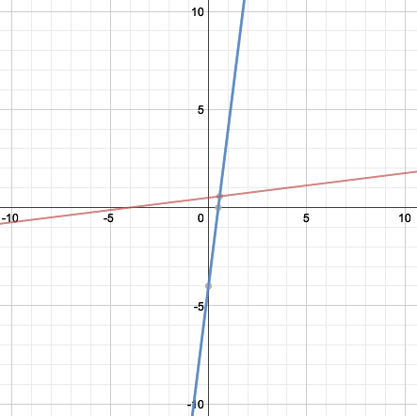

**Examples**

1. Consider the function 

1. Find the domain and range of *ƒ*.

Domain is the set of numbers greater than or equal to –1.

Range is the set of nonnegative numbers.

1. Find *ƒ* –1



1. Find the domain and range of *ƒ* –1.

Domain of *ƒ* –1 equals the range of *ƒ*, which is the set of nonnegative numbers.

Range of *ƒ* –1 is the set of numbers greater than or equal to –1.

1. Is *ƒ* –1 a function? Explain.

For each *x* in the domain of *ƒ* –1, there is only one value of *ƒ* –1(*x*). So *ƒ* –1 is a function.

**Key Concepts**

**Composition of Inverse Functions**

If f and f-1 are inverse functions, then



**Examples**

1. For the function ƒ(x) = 1/2x + 5, find (ƒ –1 ° ƒ)(652) and (ƒ ° ƒ –1)(– ).

(ƒ –1 ° ƒ)(652) = 652 (ƒ ° ƒ –1)(–) = –

**Section 6.8: Graphing Radical Functions**

**Students will be able to graph square root and other radical functions**

**Warm Up**

Using a table, graph .

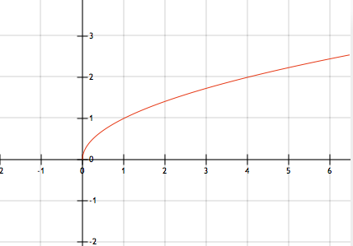

**Key Concepts**

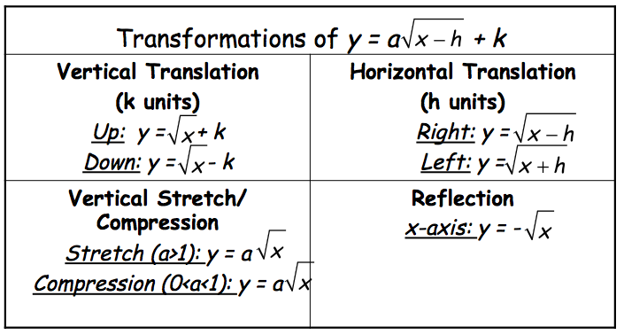

**Examples**

1. Graph .

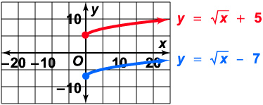

1. Graph .

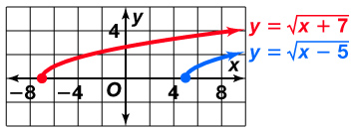

1. Graph .

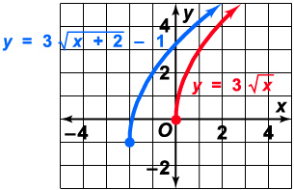

4. What is the graph of .

