Guided Notes

Chapter 2

Functions, Equations, and Graphs

Answer Key



**Unit Essential Questions**

Does it matter which form of a linear equation that you use?

How do you use transformations to help graph absolute value functions?

How can you model data with linear equations?

**2.1 Part 1: Relations and Functions**

**Students will be able to graph relations.**

**Students will be able to identify functions.**

**Warm Up**

Graph each ordered pair on the coordinate plane.

1. (-4, -8) 2. (3, 6) 3. (0, 0) 4. (-1, 3)

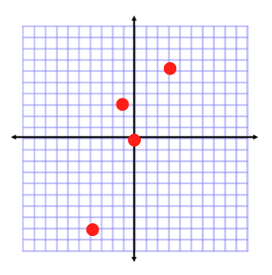

**Key Concepts**

**Relation - a set of pairs of input and output values.**

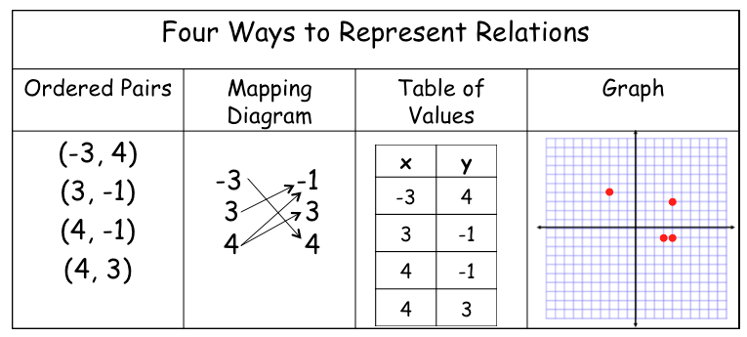

**Examples**

1. When skydivers jump out of an airplane, they experience free fall. At 0 seconds, they are at 10,000ft, 8 seconds, they are at 8976ft, 12 seconds, they are at 7696ft, and 16 seconds, they are at 5904ft. How can you represent this relation in four different ways?

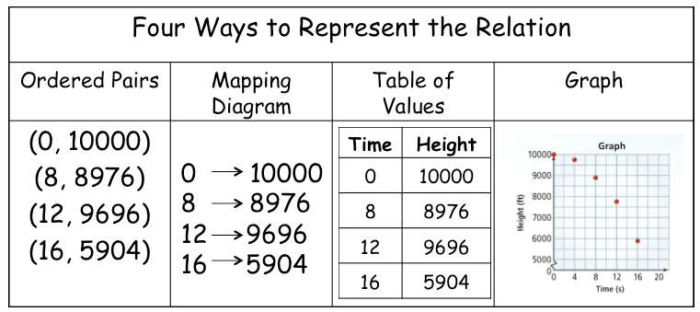

**Key Concepts**

**Domain** - the set of all inputs (*x*-coordinates)

**Range** - the set of all outputs (*y*-coordinates)

**Function** - a relation in which each element in the domain corresponds to exactly one element of the range.

**Vertical Line Test** - if any vertical line passes through more than one point on the graph of a relation, then it is *not* a function.

**Examples**

1. Determine whether each relation is a function. State the domain and range.
   1. {(0, 1), (1, 0), (2, 1), (3, 1), (4, 2)}

Domain: {0, 1, 2, 3, 4} Yes, it is a function.

Range: {0, 1, 2}

* 1. {(1, 4), (3, 2), (5, 2), (1, -8), (6, 7)}

Domain: {1, 3, 5, 6} No, it is not a function.

Range: {-8, 2, 4, 7}

* 1. {(1, 3), (2, 3), (3, 3), (4, 3), (5, 3)}

Domain: {1, 2, 3, 4, 5} Yes, it is a function.

Range: {3}

* 1. {(4, 9), (4, 3), (4, 0), (4, 4), (4, 1)}

Domain: {4} No, it is not a function.

Range: {0, 1, 3, 4, 9}

1. Use the vertical line test. Which graphs represent a function?

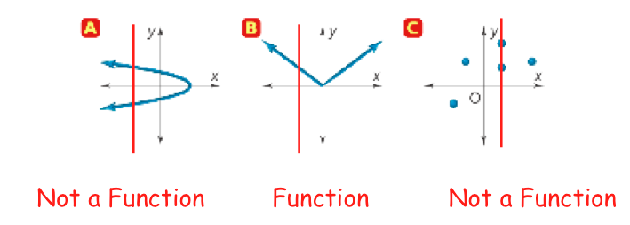

**Section 2.1 Part 2: Relations and Functions**

**Students will be able to write and evaluate functions**

**Warm Up**

1. Can you have a relation that is not a function?

yes, a relation is any set of pairs of input and output values.

1. Can you have a function that is not a relation?

no, a function is a relation.

**Key Concepts**

**Function Rule** - an equation that represents an output value in terms of an input value. You can write the function rule in function notation.

**Independent Variable** - *x*, represents the input value.

**Dependent Variable** - *y*, represents the output value. (Call dependent because it depends on the input value)

**Examples**

1. Evaluate each function for the given value of *x*, and write the input *x* and output *f* (*x*) in an ordered pair.

*f* (*x*) = −2*x* + 11 for *x* = 5, -3, and 0

*f* (5) = 1; (5, 1) *f* (-3) = 17;(-3, 17) *f* (0) = 11; (0, 11)

1. Write a function rule to model the cost per month of a long-distance cell phone calling plan. Then evaluate the function for given number of minutes.

Monthly service fee: $4.99

Rate per minute: $.10

Minutes used: 250 minutes



**2.2: Direct Variation**

**Students will be able to write and interpret direct variation equations**

**Warm Up**

Solve each equation for *y*.

1. 2. 3.



  

**Key Concepts**

**Direct Variation** - a linear function defined by an equation of the form y=*k*x, where *k* ≠ 0.

**Constant of Variation** - *k,* where *k = y/x*

**Examples**

1. For each function, determine whether *y* varies directly with *x*. If so, find the constant of variation and write the equation.

 a. b.

Does not vary directly *k* = 2; *y* = 2*x*

1. For each function, tell whether *y* varies directly with *x*. If so, find the constant of variation.
   1. 3*y* = 7*x* + 7 b. 5*x* = –2*y*

 

1. Suppose *y* varies directly with *x*, and *y* = 15 when *x* = 27. Find *y* when *x* = 18.

 

**2.3: Linear Functions and Slope-Intercept Form**

**Students will be able to graph linear equations**

**Students will be able to write equations of line**

**Warm Up**

Evaluate each expression for *x* = –2, and 0.

1. f(x) = 2*x* + 7 2. f(x) = 3*x* – 2

   

**Key Concepts**

**Slope** - the rate of change



POSITIVE NEGATIVE ZERO UNDEFINED

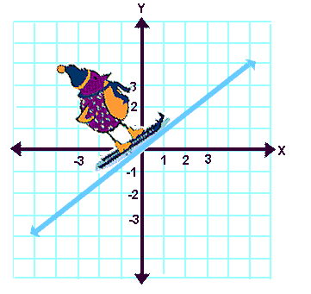 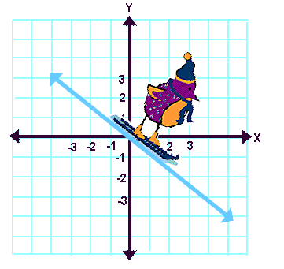 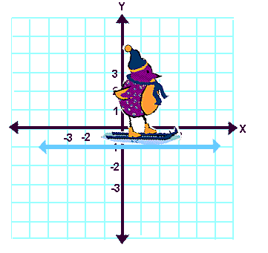 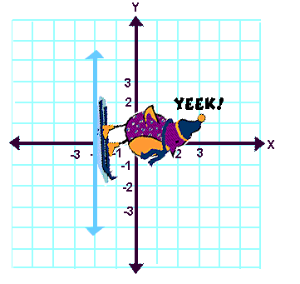

**Linear Function** - a function whose graph is a line

**Linear Equation** - represents a linear function where a solution is any ordered pair (x,y) that makes the equation true.

***x*-intercept** - the point in which a line crosses the y-axis

***y*-intercept** - the point in which a line crosses the x-axis

**Slope Intercept Form**

*y* = m*x* + b

m = slope; (0, *b*) = y-intercept

**Examples**

1. Find the slope of the line through the points:

a. (3, 0) and (5, 8) b. (1, –4) and (2, –5) c. (–2, 7) and (8, –6)

4 -1 -13/10

1. What is an equation of the line that has a slope of 1/5 and the y-intercept is (0, -3)?



1. Write the equation in slope-intercept form and then find the slope and y-intercept of

–7*x* + 2*y* = 8.

 Slope = 7/2, y-intercept = (0, 4)

1. Graph the equation *y* = 2x + 1.

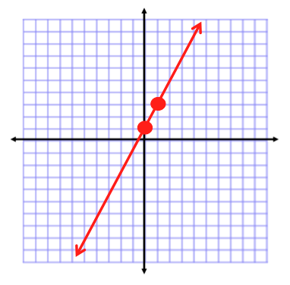

**2.4 Part 1: More about Linear Equations**

**Students will be able to write equations of lines**

**Warm Up**

Evaluate for *x* = 0.

1. 5*x* + 2 2. (*x* - 4) + 12 3. 13 - 6.5*x*

2 8 13

**Key Concepts**

**Point-Slope Form**

(y-y1) = m(x-x1)

Use this form when you are given a point (x1, y1) and the slope (m).

**Examples**

1. A line passes through (-4,1) with slope 2/5. What is the equation of the line in point-slope form?



1. Write in point-slope form an equation of the line through (4, –3) and (5, –1).



**Key Concepts**

**Standard Form of a Linear Equation**

Ax + By = C

where A, B, and C are real numbers, and A and B are not both zero.

**Steps to writing an equation in standard form:**

1. Multiply each term to clear fractions or decimals
2. Isolate the variables on the left side of the equation

**Examples**

1. Write each equation in standard form. Use integer coefficients.
2. *y* = 3/4*x* - 5 b. y = -4.2x - 5.5

 

**2.4 Part 2: More about Linear Equations**

**Students will be able to write and graph the equation of a line**

**Students will be able to write equations of parallel and perpendicular lines**

**Warm Up**

Find the slope through the following points.

1. (2, 4) and (-1, 5) 2. (-7, -8) and (-2, -8)

-1/3 0

**Key Concepts**

**Parallel Lines** - the slopes of parallel lines are equal. m1 = m2

**Perpendicular Lines** - the slopes of perpendicular lines are negative reciprocals of each other.

m1 = - 1/m2

**Examples**

1. 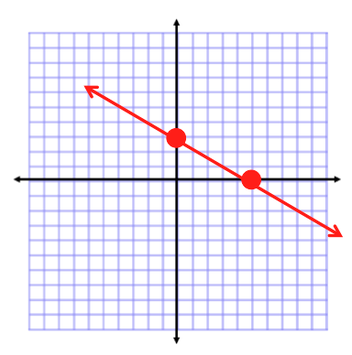What are the intercepts of 3x + 5y = 15? Graph the equation.

(5, 0) and (0, 3)

1. 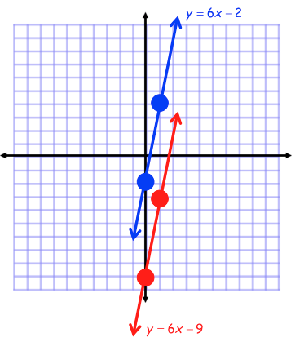Write in slope-intercept form an equation of the line through (1, –3) and parallel to

*y* = 6*x* - 2. Graph to check your answer.



1. 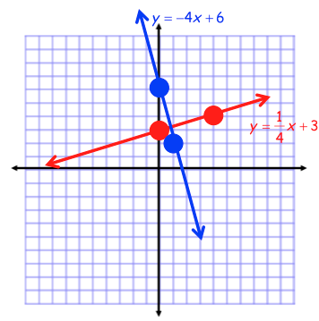Write in slope-intercept form an equation of the line through (8, 5) and perpendicular to

*y* = -4*x* + 6. Graph to check your answer.



**2.6 Part 1: Families of Functions**

**Students will be able to analyze transformations of functions**

**Warm Up**

Graph each pair of functions on the same coordinate plane.

1. y = -x 2) y = x + 1 3) y = -1/4x

y = x y = 2x - 1 y = -1/4x + 2

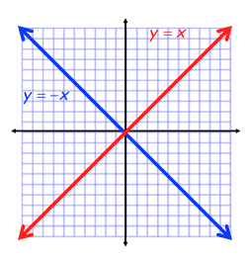 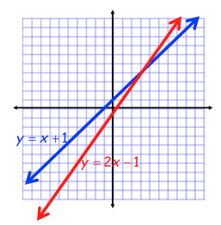 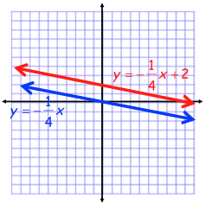

**Key Concepts**

**Parent Function** - the simplest form in a set of functions that form a family

**Translation** - operation that shifts a graph horizontally, vertically, or both.

**Vertical Translation** - moves the graph up or down, represented by *k*.

y = f(x) ± *k*

*Addition moves it up, subtraction moves it down. (Same Sign)*

**Horizontal Translation** - moves the graph right or left, represented by *h*.

y = f(x ± *h*)

*Addition moves it left, subtraction moves it right. (Opposite Sign)*

**Examples**

1. Describe how the functions *y* = 2*x* and *y* = 2*x* + 3 are related. How are their graphs related?

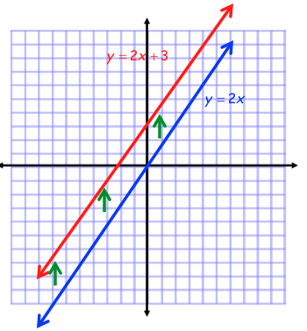y = 2x + 3 is a vertical shift up 3

units of the parent function y = 2x.

Graphs are both linear and parallel.

1. Make a table of values for f(x) = x2 and then for *g(x)* = (*x* – 5)2. Describe the transformation.

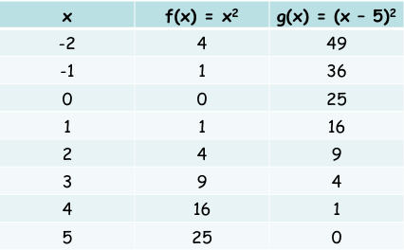

g(x) is shifted horizontally 5 units

to the right from f(x).

1. Write an equation to translate the graph of:
   1. *y* = 4*x*, 5 units down. b. *y* = 6*x*, 3 units to the right.

 

4. Write an equation for each translation of *y* = *x2*.

1. 3 units up, 7 units right



1. 5 units down, 1 unit left



**2.6 Part 2: Families of Functions**

**Students will be able to analyze transformations of functions**

**Warm Up**

Graph each pair of functions on the same coordinate plane.

1. *y* = *x*, *y* = *x* + 4 2. *y* = –2*x*, *y* = –2*x* – 3 3. *y* = *x*, *y* = *x* – 2

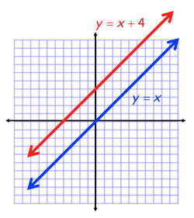 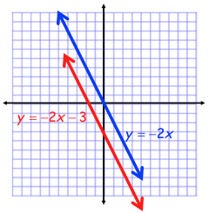 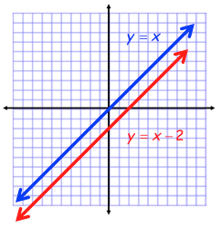

**Key Concepts**

**Reflection** - flips the graph of a function across a line such as the x- or y-axis.

*For the function f(x), the reflection in the y-axis is f(-x).

*For the function f(x), the reflection in the x-axis is –f(x)

**Examples**

1. Write the function rule for each function reflected in the given axis.

a. f(x) = 2x – 1 x-axis: y = -2x + 1

y-axis: y = -2x - 1

b. f(x) = x + 3 x-axis: y = -x – 3

y-axis: y = -x + 3

**Key Concepts**

**Vertical Stretch** - multiplies all y-values of a function by the same factor greater than 1.

**Vertical Compression** - reduces all y-values of a function by the same factor between 0 and 1.

In other words, let ***f* (*x*)** be the parent function,

* if a > 1 then y = af(x) is a vertical stretch
* if 0 < a < 1 then y = af(x) is a vertical compression

**Examples**

1. 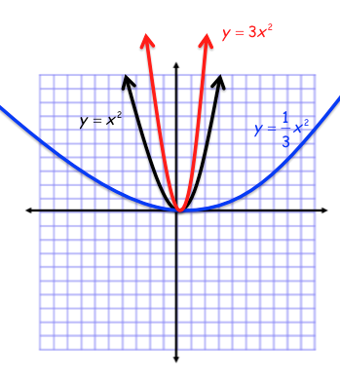Graph each of the following on the same coordinate plane and create a table of values for each. Explain the transformations from the first equation.



Stretch by 3; Compression 1/3

1. The graph of g(x) is the graph of f(x) = 6x compressed vertically by the factor 1/2 and then reflected in the y-axis. What is the function rule for g(x)?



1. What transformations change the graph of f(x) to the graph of g(x)?

f(x) = 2x2 g(x) = 6x2 – 1

Stretch by 3 units

Vertical shift down 1 unit

**Concept Summary**

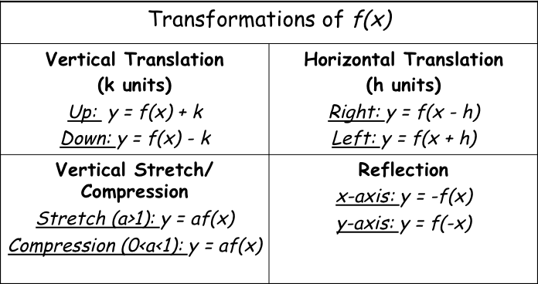

**2.7: Absolute Value Functions and Graphs**

**Students will be able to graph absolute value functions**

**Warm Up**

Solve each absolute value equation.

1.  2. 

x = 8, -2 x = 21/5, -3

**Key Concepts**

Graph of Absolute Value Function 

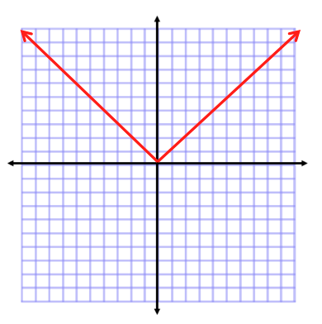

**Axis of Symmetry** - the line that divides a figure into two parts that are mirror images

**Vertex** - a point where the function reaches a maximum or minimum value

**Examples**

1. What is the graph of the absolute value function *y* = |*x*| - 4

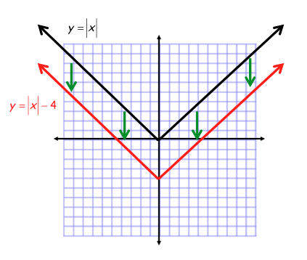

**Key Concepts**

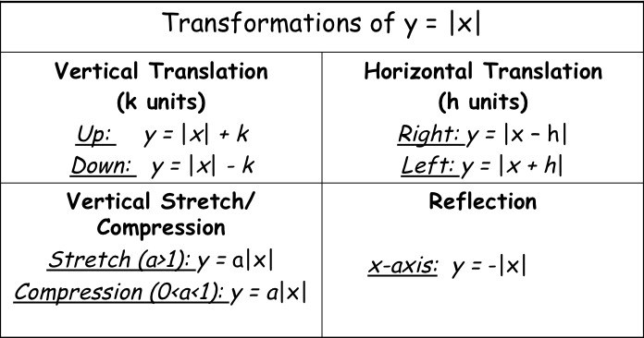

**Examples**

1. Graph each absolute value function.

a. y = |x + 2| + 3 b. y = 1/2|x|

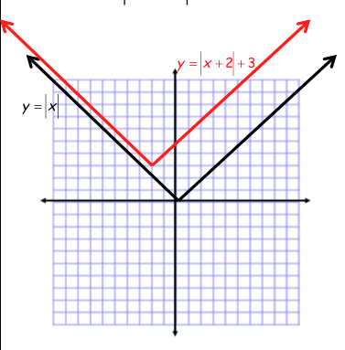 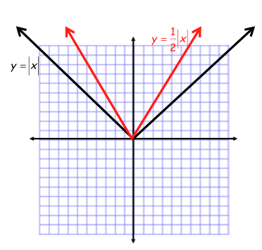

**Key Concepts**

**General Form of the Absolute Value Function**

y = a |x-h| + k

Stretch/Compression Factor is |a|, Vertex is (h, k), Axis of Symmetry is x = h

**Examples**

1. Without graphing, identify the vertex, axis of symmetry, and transformations of

*f(x)* = -3|*x* – 1| + 4 from the parent function *f(x)* = |*x*|.

Vertex: (1, 4), Axis of Symmetry: x = 1

Stretch by 3 units, Reflect over the x-axis, Horizontal shift right 1 unit,

Vertical shift up 4 units

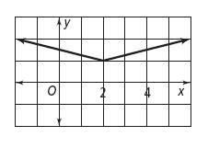

1. Write an absolute value equation for the given graph.



**2.8: Two Variable Inequalities**

**Students will be able to graph two-variable inequalities**

**Warm Up**

Solve each inequality. Graph the solution on a number line.

1.  2.  3. 

*p ≤* 5/4 *t* > 13 *t ≤* -3

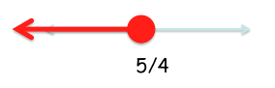 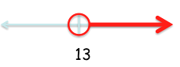 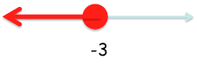

**Key Concepts**

**Linear Inequality** -an inequality in two variables whose graph is a region of the coordinate plane that is bounded by a line.

**Steps to graph two-variable inequality:**

1. Graph the boundary line (graph as if it was an equation)

* If y< or y>, then the boundary is dashed. If y≥ or y≤, then the boundary is solid.

1. Shade the solutions

* For y< or y≤, shade below the boundary. For y> or y≥, shade above the boundary.

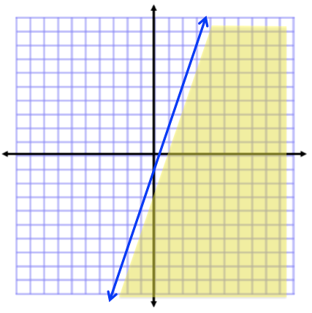**Examples**

1. Graph

1. 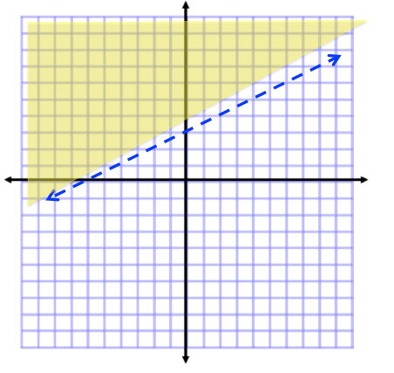Graph 

1. 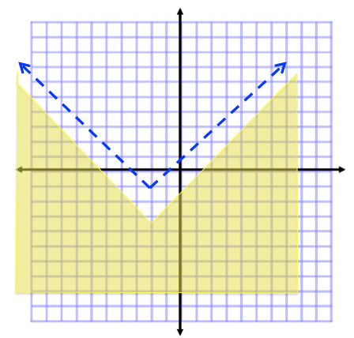Graph 