Guided Notes  
Chapter 7  
Exponential and Logarithmic Functions

Answer Key



**Unit Essential Questions**

How do you model a quantity that changes regularly over time by the same percentage?

How are exponents and logarithms related?

How are exponential functions and logarithmic functions related?

**Section 7.1: Exploring Exponential Models**

**Students will be able to model exponential growth and decay**

**Warm Up**

Evaluate each expression for the given value of *x*.

1. 2*x* for *x* = 3

8

2. 23*x*+4 for *x* = –1

2

3. (1/2)*x*for *x* = 0

1

**Key Concepts**

**Exponential function** - a function with the general form y=abx, where x is a real number, a ≠ 0, b > 0, and b ≠ 0.

**Growth factor** - when b > 1

**Decay factor** - when 0 < b < 1

**Asymptote**- a line that a graph approaches as x or y increases in absolute value.

**Examples**

1. Graph *y* = 3*x*.

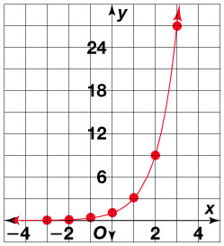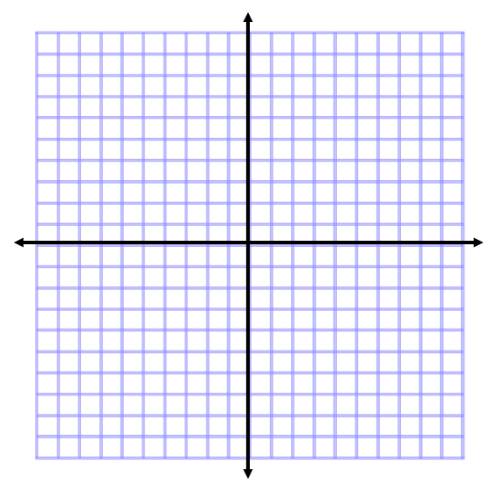

1. Without graphing, determine whether the function *y* = 3 (2/3)*x* represents exponential growth or decay.

Exponential decay

1. Graph *y* = 6(0.5)*x*. Identify the horizontal asymptote.

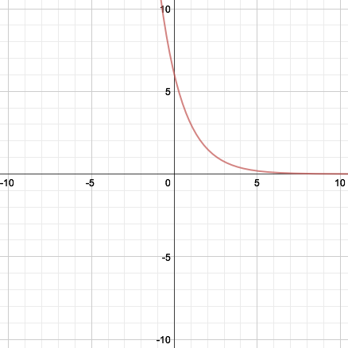

The horizontal asymptote is the *x*-axis, *y* = 0.

**Key Concepts**

When a real-life quantity increases by a fixed percent each time period, the amount **A** of the quantity after **t** time periods (usually years) can be modeled by the equation

A = P(1 ± r)t

Where **A** is the **final amount**, **P** is the **Principal (initial amount**) and **r** is the **percent** increase/decrease as a decimal. **The amount (1** ± **r) is called the growth/decay factor.**

**Examples**

1. You invested $1000 in a savings account at the end of 6th grade. The account pays 5% annual interest. How much money will be in the account after 6 years?

**≈** $1340.10

**Section 7.2 Part 1: Properties of Exponential Functions**

**Students will be able to explore functions in the form *y* = *abx***

**Warm Up**

Write an equation for each translation.

1. *y* = | *x* |, 1 unit up, 2 units left2. *y* = *x*2, 2 units down, 1 unit right

*y* = | *x* + 2 | + 1 *y* = (*x* – 1)2 – 2

**Key Concepts**

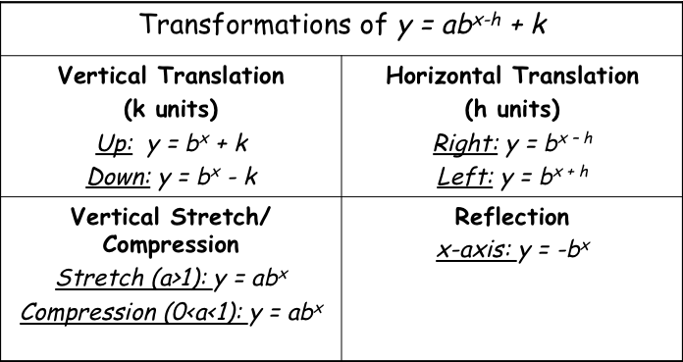

\***Remember** – If the graph shifts up or down, so does the horizontal asymptote!

**Examples**

1. Graph *y* = 3 (2)*x* and *y* = –3 (2)*x*. Label the asymptote of each graph.



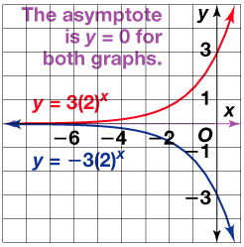

1. Graph *y* = 6 (1/2)x and *y* = 6 (1/2)x - 3 – 2.

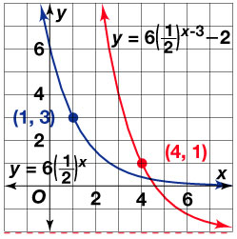

**Section 7.2 Part 2: Properties of Exponential Functions**

**Students will be able to graph exponential functions with base *e***

**Warm Up**

Graph each function.

1. *y* = 3*x* 2*.* *y* = 0.75*x* 3*. y* = 0.5 (4)*x*

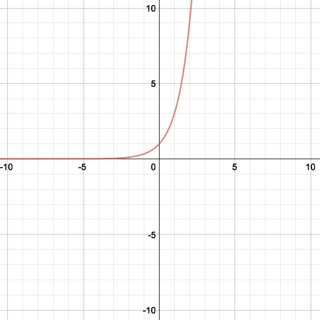 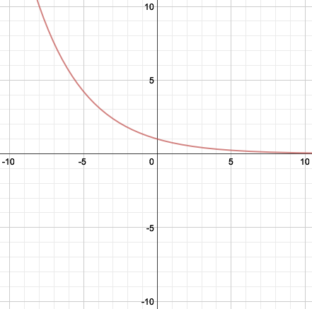 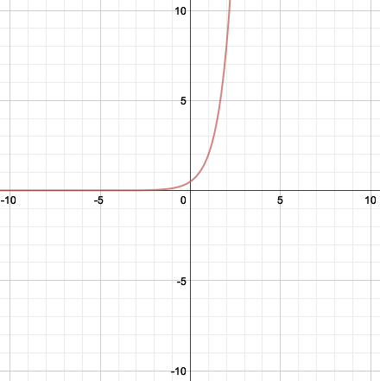

**Key Concepts**

***e*** - an irrational number approximately equal to 2.71828

*e* is useful for describing continuous growth or decay.

**Examples**

1. Graph *y* = *ex*. Evaluate *e*3 to four decimal places.

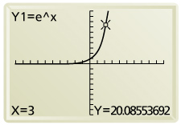

20.0855

**Key Concepts**

Continuously Compounded Interest Formula

*A* = *Pert*

* A = amount in account
* P = principal
* r = annual rate or interest
* t = time in years

**Examples**

1. Suppose you invest $100 at an annual interest rate of 4.8% compounded continuously. How much will you have in the account after 3 years?

$115.49

**Section 7.3: Logarithmic Functions as Inverses**

**Students will be able to write and evaluate logarithmic expressions**

**Students will be able to graph logarithmic functions**

**Warm Up**

Solve each equation.

1. 8 = *x*32. *x*1/4 = 2

2 16

3. 27 = 3*x* 4. 46 = 43*x*

3 2

**Key Concepts**

Logarithm- has base *b* of a positive number *y* is defined as follows:

If y = bx, then logb y = x.

Common logarithm- a logarithm that uses base 10. ex. log 8

**Examples**

1. Write in logarithmic form.

a)  b)  c) 

  

1. Write in exponential form.

a)  b)  c) 

  

1. Evaluate.

a) log3 81 b) 

4 1/3

**Key Concepts**

Logarithmic function- the inverse of an exponential function.

|  |  |  |
| --- | --- | --- |
| Characteristics | y = logbx | y = logb(x – h) + k |
| Asymptote | x = 0 | x = h |
| Domain | x > 0 | x > h |
| Range | All real numbers | All real numbers |

**Examples**

1. Graph *y* = log4 *x.*



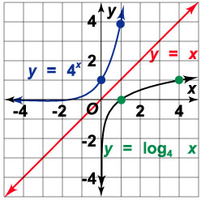

1. Graph *y* = log5 (*x* – 1) + 2.



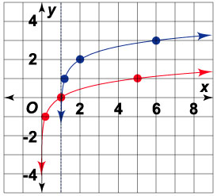

**Section 7.4: Properties of Logarithms**

**Students will be able to use properties of logarithms**

**Warm Up**

Evaluate each expression for *x* = 3.

1. *x*3 – *x* 2. *x*5 *x*23. *x*3 + *x*2

24 2187 36

**Key Concepts**

**Properties of Logarithms**

logbMN = logbM + logbN Product Property

logbM/N = logbM – logbN Quotient Property

logbMn = nlogbM Power Property

**Examples**

1. Write each logarithmic expression as a single logarithm.
2. log4 64 – log4 16 b. 6 log5 *x* + log5 *y*

1 log5 (*x*6*y*)

1. Expand each logarithm.
2. log7 (*t*/*u*) b. log(4*p*3)

log7 *t* – log7 *u* log 4 + 3 log *p*

**Key Concepts**

**Change of Base Formula**: logb M = logc M**/**logcb

**Examples**

1. Use the Change of Base Formula to evaluate log612.

≈1.387

**Section 7.5: Exponential and Logarithmic Equations**

**Students will be able to solve exponential equations**

**Students will be able to solve logarithmic equations**

**Warm Up**

Write each expression as a single logarithm. State the property you used.

1. log 12 – log 3 2. 3 log115 + log117

log 4; Quotient Property log11(53 • 7); Power Property and

Product Property

Expand each logarithm.

3. log*c(a/b)* 4. log3*x*4

log*ca* – log*cb 4 log3x*

**Key Concepts**

Exponential Equation - an equation of the form bcx = a, where the exponent includes a variable.

Steps to Solving Exponential Equations

1. Isolate the exponential expression
2. Take the logarithm of each side.
3. Use the Power Property of Logarithms
4. Solve

**Examples**

1. Solve 52*x* = 16.

x≈ 0.8614

1. Solve 7 – 52x – 1 = 4.

x≈ 0.8413

**Key Concepts**

Logarithmic Equation - an equation that includes a logarithmic expression.

Steps to Solving Logarithmic Equations

1. Write as a single logarithm
2. Write in exponential form
3. Solve

**Examples**

1. Solve log (2*x* – 2) = 4

*x* = 5001

1. Solve 3 log *x* – log 2 = 5.

*x* ≈ 58**.**48