Guided Notes

Chapter 4  
Quadratic Functions and Equations

Answer Key



**Unit Essential Questions**

What are the advantages of a quadratic function in vertex form?

How is any quadratic function related to the parent quadratic function

y = x2?

How are the real solutions of a quadratic equation related to the graph of the related quadratic function?

**Section 4.1: Quadratic Functions and Transformations**

**Students will be able to identify and graph quadratic functions**

**Warm Up**

Evaluate each function for *x* = -3 and 3.

1. ƒ (*x*) = *x* 2. ƒ (*x*) = *x*2 3. ƒ (*x*) = –*x* 4. ƒ (*x*) = –*x*2

f(-3) = -3, f(3) = 3 f(-3) = 9, f(3) = 9 f(-3) = 3, f(3) = -3 f(-3) = -9, f(3) = -9

**Key Concepts**

**Quadratic Function** - a function that can be written in the standard form

*f*(x)=*a*x²+*b*x+*c*, where *a* ≠ 0

**Parabola** - the graph of a quadratic function

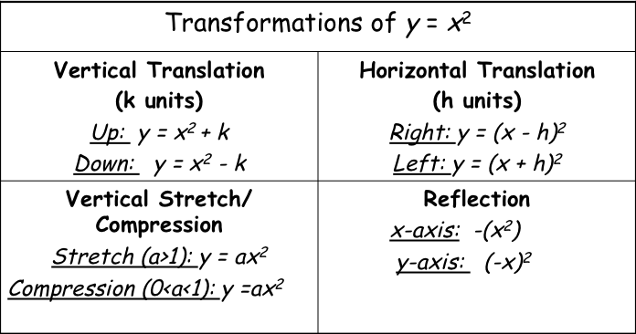

**Vertex form of a Quadratic Function**

**y = *a* ( x – *h* )2 + *k***

1. The graph has a vertex (h, k)
2. The graph has an axis of symmetry at x = h
3. The graph opens up if a > 0 and opens down if a < 0
4. The domain is all real numbers.
5. The range is determined by the vertex and how the graph opens

**Examples**

1. 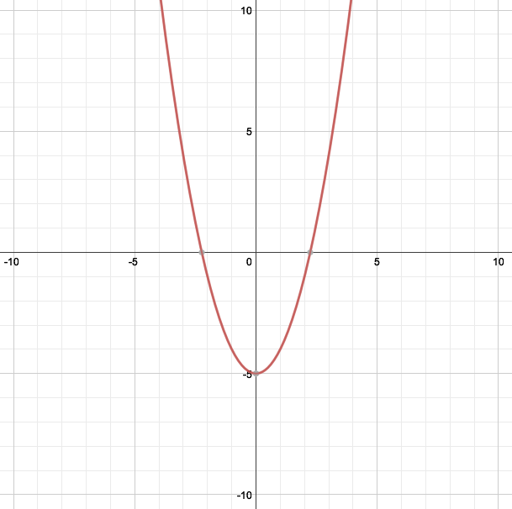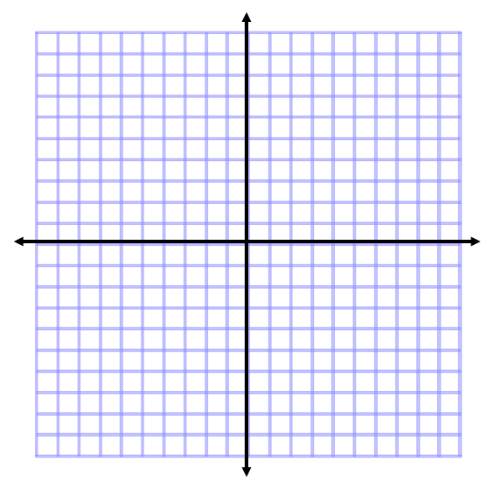Graph the function *f(x) = x2 – 5*. How is the graph a translation of the graph of the parent function *f(x)* = x2?

The graph shift down 5

units from the parent

function

1. 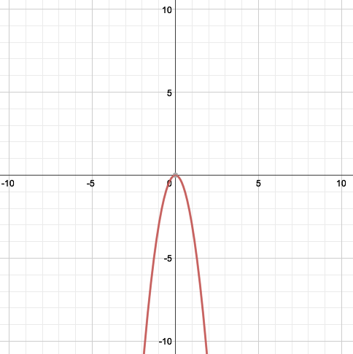 Graph the function *f(x) = -3x2*. How is the graph a translation of the graph of the parent function *f(x)* = x2?



The graph reflects and

stretches by 3 from the

parent function

1. For *f(x)* = 3(*x* – 4)2 – 2, what are the vertex, the axis of symmetry, the maximum or minimum value, and the domain and the range?

Vertex = (4, -2)

Axis of Symmetry: x = 4

Minimum = -2

Domain: All real numbers

Range: y ≥ -2

1. For *f(x)* = -2(*x* + 3)2 + 1, what are the vertex, the axis of symmetry, the maximum or minimum value, and the domain and the range?

Vertex = (-3, 1)

Axis of Symmetry: x = -3

Maximum = 1

Domain: All real numbers

Range: y ≤ 1

**Section 4.2 Part 1: Standard Form of a Quadratic Function**

**Students will be able to graph quadratic functions written in standard form**

**Warm Up**

Find the slope and *y*-intercept of the graph of each function.

1. *y =* 3*x* + 3 2. y = –2*x* – 1 3. 3x + 2y = 6

Slope = 3, Slope = -2, Slope =-3/2,

y-intercept = (0, 3) y-intercept = (0, -1) y-intercept = (0, 3)

**Key Concepts**

**Steps to Graph Quadratic Equations in Standard Form:**

1. Put the equation in standard form: y = *a*x² + *b*x + *c*
2. Extract the values for *a*, *b*, and *c*.
3. Find the axis of symmetry: x = -*b****/****2a*
4. Find your vertex: substitute your “axis of symmetry” x value back into the original equation and solve for y.
5. Construct a table of more values for x and y. (Choose values for x to the left and right of your vertex “x” value. Substitute x-values into original equation to find y-values.)
6. Plot the points and connect them with a U-shaped curve.

**Examples**

1. Graph x2 – 4x - 4 using a table of values.

Find the axis of symmetry, vertex, and the maximum or minimum value. (Use a dotted line to graph the axis of symmetry)

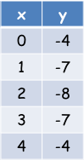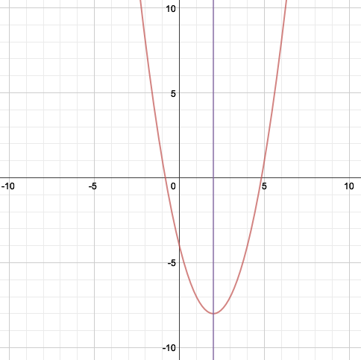

Vertex = (2, -8)

Axis of Symmetry: x = 2

Minimum = -8

1. Solve the system by substitution. Graph x2 – 6x + 5 using a table of values.

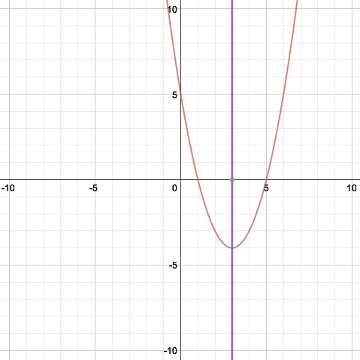Find the axis of symmetry, vertex, and the maximum or minimum value. (Use a dotted line to graph the axis of symmetry)

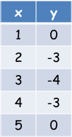

Vertex = (3, -4)

Axis of Symmetry: x = 3

Minimum = -4

1. Sketch the parabola using the given information: vertex (3, 6) and the point (0,2) on the graph.

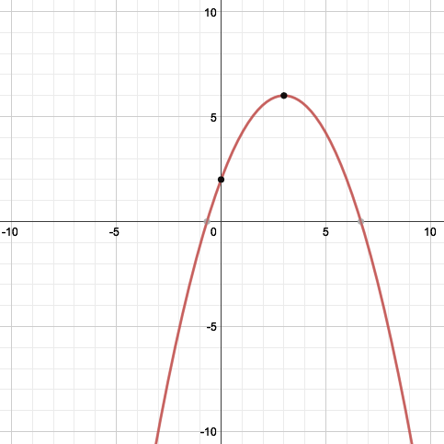

**Section 4.2 Part 2: Standard Form of a Quadratic Function**

**Students will be able to write quadratic functions in standard form**

**Warm Up**

Find the vertex of the graph of each function.

1. y = | *x* |+ 5 2. *y* = | *x* + 7 |- 3

(0, 5) (-7, -3)

**Key Concepts**

**Vertex Form of a Quadratic Function**

y = *a* ( x – *h* )2 + *k*

**Steps to Graph Quadratic Equations in Vertex Form:**

1. Identify “*a”* and “*b”* from the standard form of the equation.
2. Find the vertex by using:x=-b**/**2a*,* then plug it in to find: y=f(-b**/**2a).
3. Write the equation in vertex form by replacing *“h”* withx=-b**/**2a *and “k” with* y = f(-b**/**2a)*.* Finally insert *“a”* from the standard form as *“a”* in the vertex form--as they are the same value in both

**Examples**

1. Write *y* = –*x*2 + 4*x* – 5 in vertex form.



1. Write *y* = 2*x*2 + 12*x* + 7 in vertex form.



**Section 4.4 Part 1: Factoring Quadratic Expressions**

**Students will be able to factor using greatest common factor**

**Warm Up**

Multiply

1. 3(x – 2) 2. x(x - 9) 3. (x + 5)(x – 9) 4. x2(x2 - 4x + 5)

3x – 6 x2 – 9x x2 - 4x – 45 x4 - 4x3 + 5x2

**Key Concepts**

**Factoring** - rewriting an expression as the product of its factors. (un-distributing)

**Greatest Common Factor (GCF)** – the largest quantity that is a factor of all the integers or polynomials involved.

**Examples**

1. Find the GCF of each list of numbers.

a. 12 and 8 b. 7 and 20

4 1

1. Find the GCF of each list of terms.

a. *x*3 and *x*7  b. 6*x*5 and 4*x*3

*x*3 2*x*3

1. Factor.

a. 15x2 + 100 b. 8m2 + 4m c. 3x2 + 6x

5(3x2 – 20) 4m(2m + 1) 3x(x + 2)

1. Factor out the GCF in each of the following polynomials.

a. 6*x*3 – 9*x*2 + 12*x* b. 14*x*3*y* + 7*x*2*y* – 7*xy*

3*x*(2*x*2 – 3*x* + 4) 7*xy*(2*x*2 + *x* – 1)

1. Factor out the GCF in each of the following polynomials.

a. 6(*x* + 2) – *y*(*x* + 2) b. *xy*(*y* + 1) – (*y* + 1)

(*x* + 2)(6 – *y*) (*y* + 1)(*xy* – 1)

**Section 4.4 Part 2: Factoring Quadratic Expressions**

**Students will be able to factor using grouping**

**Warm Up**

**Factor out the GCF.**

**1. x(x + 2) – 3(x + 2) 2. x2(x – 1) + (x – 1) 3. 4x(y + 12) + (y + 12)**

**(x – 3)(x + 2) (x2 + 1)(x – 1) (4x + 1)(y + 12)**

**Key Concepts**

**Factor by Grouping** – factor a polynomial by grouping the terms of the polynomial and looking for common factors.

**Factoring by Grouping (4 terms)**

ax + ay + bx + by = a(x + y) + b(x + y) = (a + b)(x + y)

**Examples**

1. Factor *x*3 + 2*x*2 – 3*x* – 6.

(x2 – 3)(x + 2)

1. Factor *x*3 + 4*x* + *x*2 + 4.

(*x*2 + 4)(*x* + 1)

1. Factor 2*x*3 – *x*2 – 10*x* + 5.

(2*x* – 1)(*x*2 – 5)

**Section 4.4 Part 3: Factoring Quadratic Expressions**

**Students will be able to factor a trinomial with leading coefficient = 1**

**Warm Up**

Multiply.

1. (x + 2)(x – 5) 2. (y – 7)(x – 1) 3. (x + y)(2x – y)

x2 - 3x – 10 xy - y - 7x + 7 2x2 + xy – y2

**Key Concepts**

**Factoring Trinomials with Leading Coefficient = 1**

1. Factor a GCF if possible
2. Find two numbers that multiply to the last term and add to the middle term.
3. FOIL to check

**Examples**

1. Factor

a. *x*2 + 10*x* + 24 b. *x*2 – 4x – 12 c. *x*² – 14*x* + 33

(x + 6)(x + 4) (x - 6)(x + 2) (x - 11)(x - 3)

1. Factor

a. 2x2 + 6*x* –56. b. -t² + 6t – 5

2(x + 7)(x – 4) - (t - 5)(t - 1)

**Section 4.4 Part 4: Factoring Quadratic Expressions**

**Students will be able to factor a trinomial with leading coefficient ≠ 1**

**Warm Up**

Write 2 different expressions that have a factor of (*x* + 6).

Answers Vary

Examples: x2 + 6x and x2 + 5x – 6

**Key Concepts**

**Steps for Factoring with a Leading Coefficient ≠ 1**

1. Find factors that add to *b* and multiply to *ac.*
2. Split the “b” term with the two values your found in step 1.
3. Factor by grouping.

**Examples**

1. Factor: 5*x*2 - 13*x* + 6

(5x – 3)(x – 2)

1. Factor: 2*x*2 + 9*x* – 5

(2x – 1)(x + 5)

1. Factor: 5x² + 28x + 32

(5x + 8)(x + 4)

**Section 4.4 Part 5: Factoring Quadratic Expressions**

**Students will be able to factor special quadratic expressions**

**Warm Up**

Multiply

1. (2*x* – 7)(2*x* – 7) 2. (4*x* + 3)(4*x* – 3)

4x2 - 28x +49 16x2 - 9

**Key Concepts**

Special Cases

Perfect Square Trinomial

a2 + 2ab + b2 = (a + b)(a + b) = (a + b)2

Or

a2 - 2ab + b2 = (a – b)(a – b) = (a - b)2

Difference of Two Square

a2 – b2 = (a + b)(a – b)

**Examples**

1. Factor: *x*2 + 10*x* + 25

(x + 5)2

1. Factor *x*2 - 18*x* + 81

(x - 9)2

1. Factor: *x*² – 16

(x + 4)(x – 4)

1. Factor 25*x*² – 121

(5x + 11)(5x – 11)

**Section 4.5: Quadratic Equations**

**Students will be able to solve a quadratic equation by factoring**

**Warm Up**

Factor.

1. x2 + 5x – 14 2. 4*x*2 – 12x 3. 9*x*2 – 16

(x + 7)(x – 2) 4x(x – 3) (3x – 4)(3x + 4)

**Key Concepts**

**Standard Form of a Quadratic Equation**

ax² + bx + c = 0

**Zero-Product Property**

If ab = 0, then a = 0 or b = 0.

**Zero of a function** - a solution of a quadratic equation. The x-intercepts of the parabola.

**Examples**

1. Solve by factoring *x*2 – 5*x* + 6 = 0



1. Solve by factoring 3*x*2 – 20*x* – 7 = 0



1. Solve by factoring *x*2 – 18 = 3*x*



**Section 4.6 Part 1: Completing the Square**

**Students will be able to solve perfect square trinomial equations**

**Warm Up**

Simplify:

1. (2*x* – 1)(2*x* – 1) 2. (*x* + 4)(*x* + 4) – 3

4x2 - 4x + 1 x2 + 8x + 13

**Examples**

1. Solve by finding the square roots.
   1. 3*x2* - 5 = 7 b. 4*x2* + 10 = 46

 

**Key Concepts**

**Perfect square trinomial**- the product you obtain when you square a binomial.

**Examples**

1. What are the solutions to x2 + 4x + 4 = 25?



1. What are to solutions of *x*2 – 14*x* + 49 = 81?



**Section 4.6 Part 2: Completing the Square**

**Students will be able to solve equations by completing the square**

**Warm Up**

Solve:

1. 2*x*2 = 72 2. 6x2 = 54

x = ± 6 x = ± 3

**Key Concepts**

**Completing the square** - the process of finding the last term of a perfect square trinomial.

x² + bx + (b/2)² = (x + (b/2))²

**Examples**

1. Find the missing value to complete the square.

1. x2 + 20*x* b. *x*2 + 18*x*

100 81

**Key Concepts**

**Step to solving by completing the square**

1. Make sure leading coefficient = 1.
2. Isolate the terms with the variable
3. Add (b/2)2 to both sides
4. Factor the perfect square trinomial
5. Solve

**Examples**

1. Solve *x*2 + 6*x* - 12 = 0.



1. Solve 2*x*2 + 8*x* – 2 = 0.



**Section 4.7: The Quadratic Formula**

**Students will be able to solve quadratic equations using the quadratic formula**

**Warm Up**

Write each quadratic in standard form.

1. y = 8 – 10*x*2 2. *y* = (*x* + 2)2 – 1

 

**Key Concepts**

**The Quadratic Formula**



**Examples**

1. Use the Quadratic Formula to solve 3*x*2 + 23*x* + 40 = 0.



1. Solve 3*x*2 + 2*x* = 4



**Section 4.8 Part 1: Complex Numbers**

**Students will be able to perform operations with complex numbers**

**Warm Up**

Simplify.



2 11 -8 Not Real

**Key Concepts**

***i* -** the imaginary number that is defined as the number whose square is -1.

***i2* =** -1

**Examples**

1. Simplify.



 

1. Simplify (3 + 6*i*) – (4 – 8*i*).

-1 + 14i

1. Find each product.
2. (3*i*)(8*i*) b) (3 – 7*i*)(2 – 4*i*)

-24 -22 – 26i

**Section 4.8 Part 2: Complex Numbers**

**Students will be able to find complex number solutions of quadratic equations**

**Warm Up**

Solve 2*x*2 – 32 = 0



**Examples**

1. Solve 9*x*2 + 54 = 0



1. Solve x2 + 5 = 4x

