**13-1 Exploring Periodic Data**

**State Standards**

**A2. F.LE.A.2** (formerly F-TF.A.2) Explain how the unit circle in the coordinate plane enables the extension of trigonometric functions to all real numbers, interpreted as radian measures of angles traversed counterclockwise around the unit circle.

**Objectives**

The students will identify cycles, periods and amplitude in periodic functions.

**Key Concepts**

___________________________________- a function that repeats a pattern of *y*-values at regular intervals.

_________________- one complete pattern

_________________- the horizontal length of one cycle

______________________- half the difference of the maximum and minimum values

**Examples**

1. Identify the cycle in the periodic function. State the period.

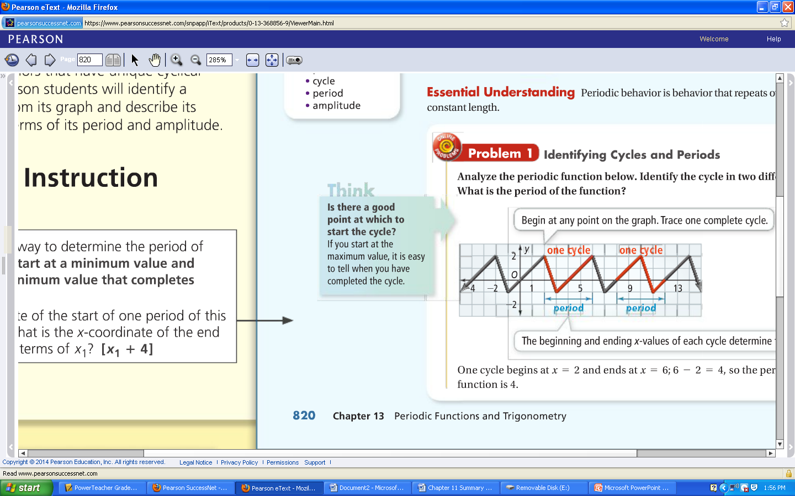

2. Is the function periodic? If so, state the period.

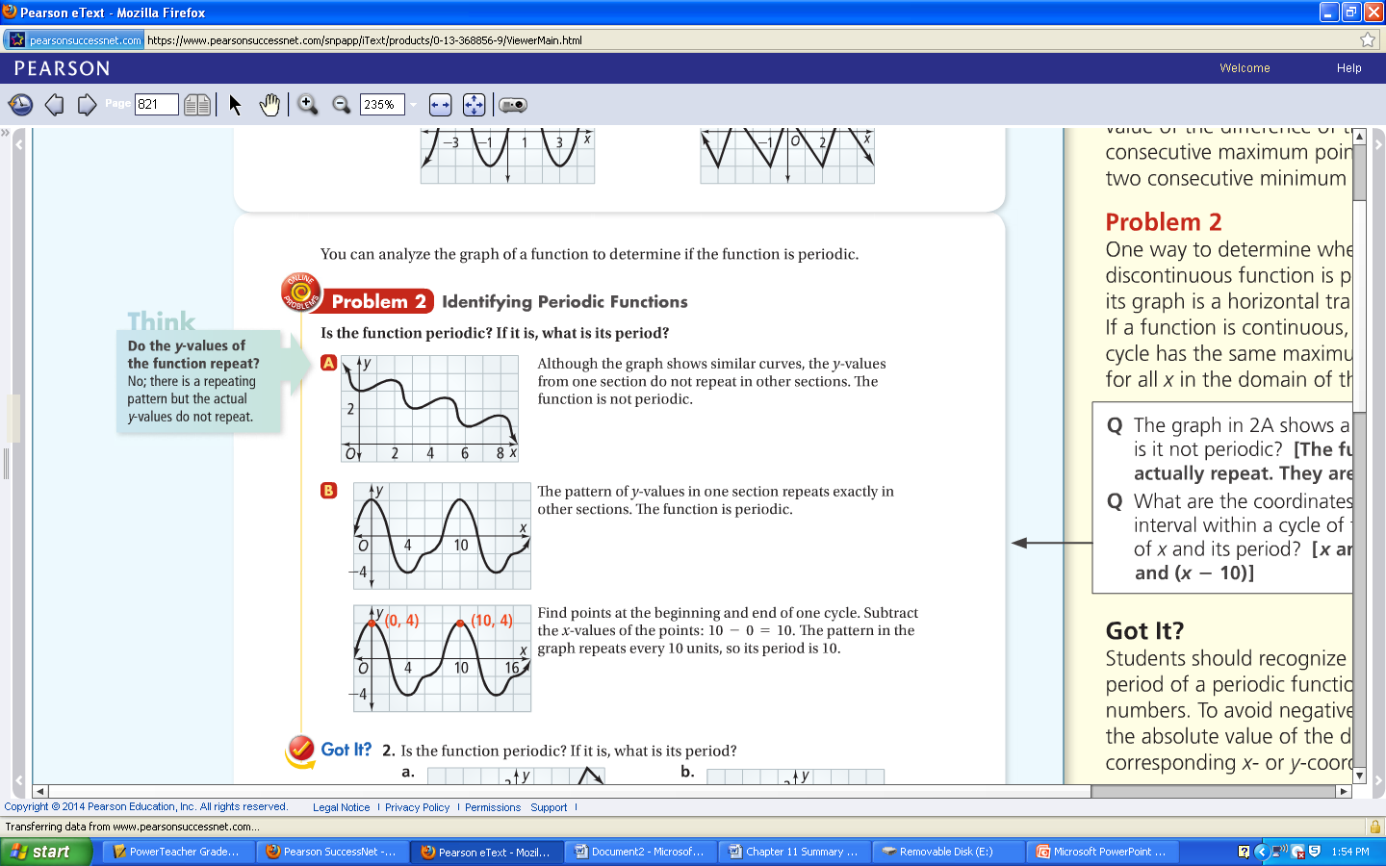

3. Find the amplitude of the periodic function.

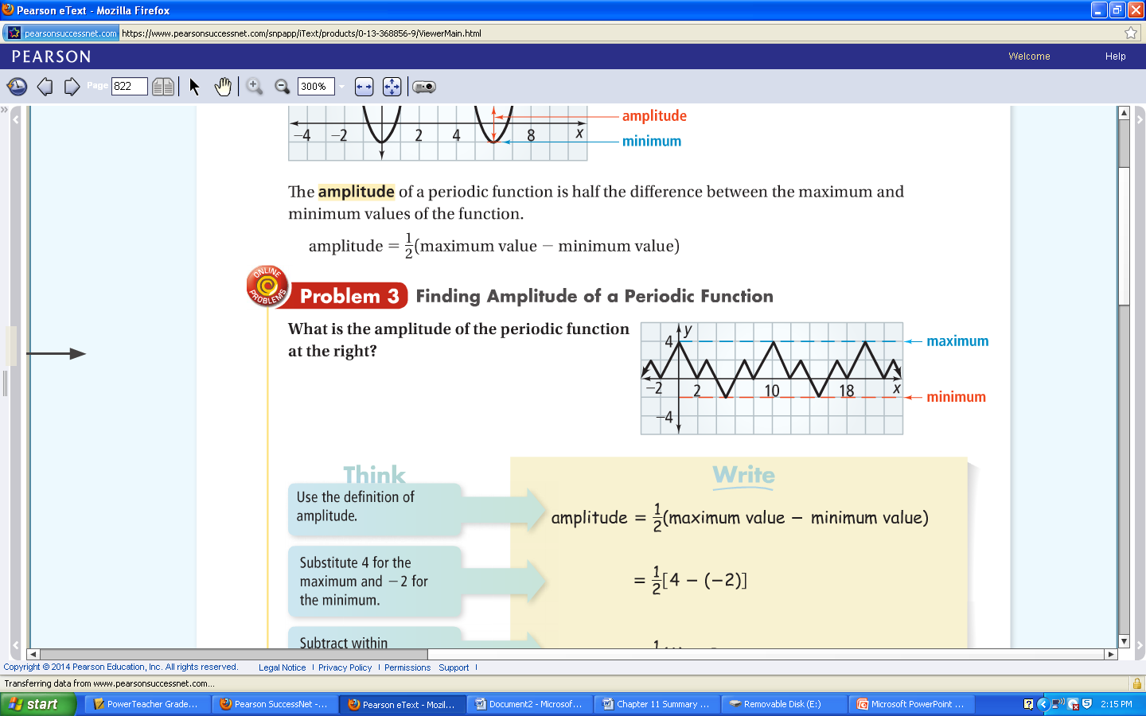

**Practice 13-1: Complete your assignment on a separate sheet of paper. Show all work.**

1. Determine if the function is periodic. If so, find the period.
   1. 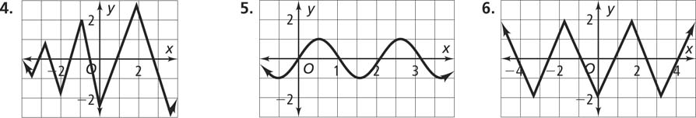b.
2. Name a cycle two different ways. Then determine the period and amplitude.
   1. 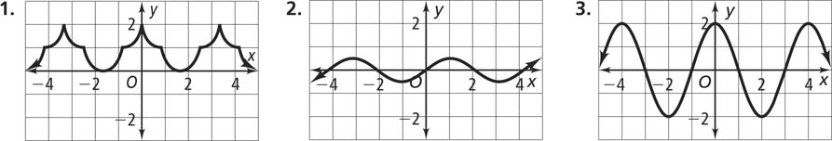b.
3. Sketch the graph of a periodic function with period 8 and amplitude 3. State the maximum and minimum of your function.

**13-2 Angles and the Unit Circle**

**State Standards**

**A2. F.LE.A.1** (formerly F-TF.A.1) Understand and use radian measure of an angle.

Understand radian measure of an angle as the length of the arc on the unit circle subtended by the angle. Use the unit circle to find sin θ, cos θ, and tan θ when θ is a commonly recognized angle between 0 and 2π.

**Objective**

The students will work with angles in standard position and find the coordinates of points on the unit circle.

**Key Concepts**

___________________________________- when the vertex is at the origin and one ray is on the positive y-axis.

_________________________________- the ray on the x-axis of an angle in standard position.

_________________________________-the other ray of an angle in standard form.

_________________________________- 2 angles in standard position when they have the same terminal side.

_________________________________- has a radius of one and its center at the origin. Points on the circle are related to periodic functions.

**Examples**

1. What is the measure of each angle?

a. b.



2. What is the measure of each angle?

a. b.



3. Sketch each angle in standard position.

a. 35 $°$

b. -320

c. 315

4. Identify a coterminal angle for the following.

a. 300 $°$

b. -225

c. 90

5. Use the unit circle to determine $\cos{θ}and\sin{θ}$ for $θ=30, 60, 90, -180 \& 270$

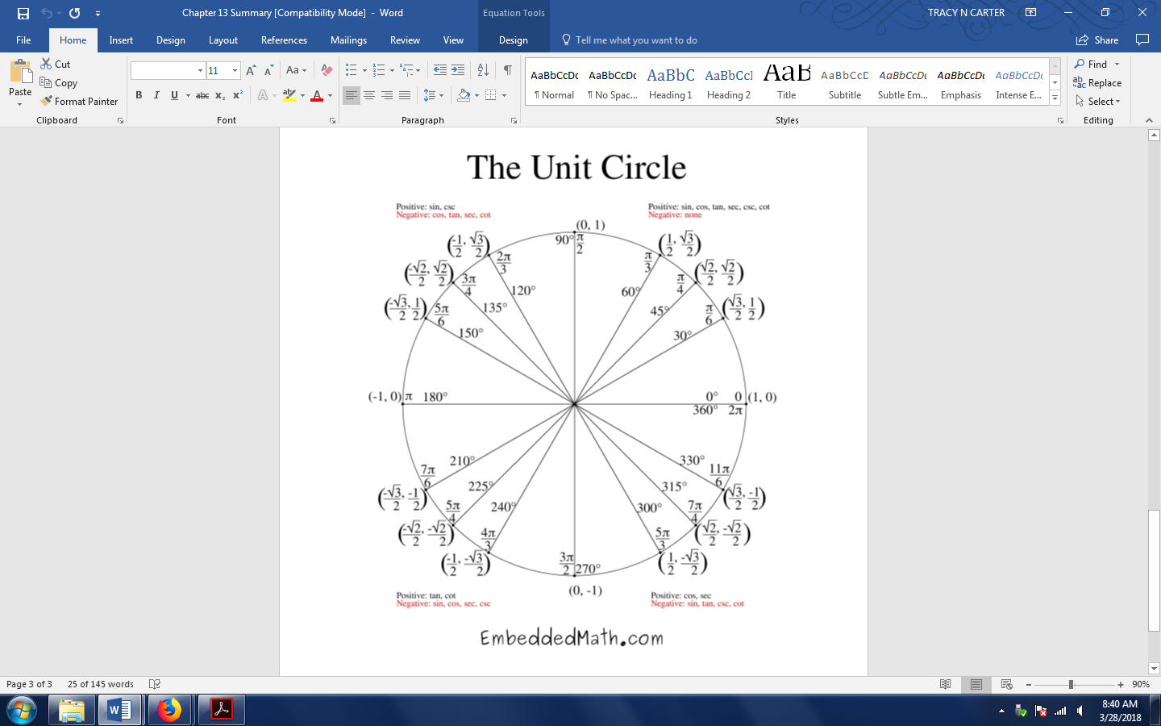

**Practice 13-2: Complete your assignment on a separate sheet of paper. Show all work.**

**1.** Find the measure of each angle in standard form.

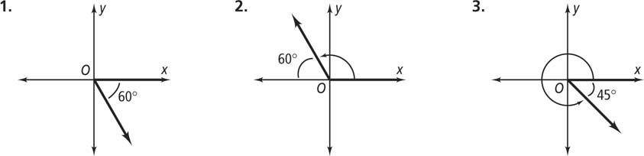a.b.

**2.** Sketch the angle in standard position.

a.100 $°$ b. 210 $°$ c. -45 $°$

**3.** Identify a coterminal angle for the following.

a. -100 $°$ b. 409 $°$ c. -145 $°$

**13-3 Radian Measure**

**State Standards**

**A2. F.LE.A.1** (formerly F-TF.A.1) Understand and use radian measure of an angle.

Understand radian measure of an angle as the length of the arc on the unit circle subtended by the angle. Use the unit circle to find sin θ, cos θ, and tan θ when θ is a commonly recognized angle between 0 and 2π.

**Objective**

The students will use radian measure for angles and find the length of an arc of a circle.

**Key Concepts**

_____________________________ - an angle with the vertex at the center of the circle.

_____________________________ - the portion of the circle with endpoints on the sides of the central angle and remaining points within the interior of the angle.

___________________________-the measure of a central angle that intercepts an arc.

**Key Concept**

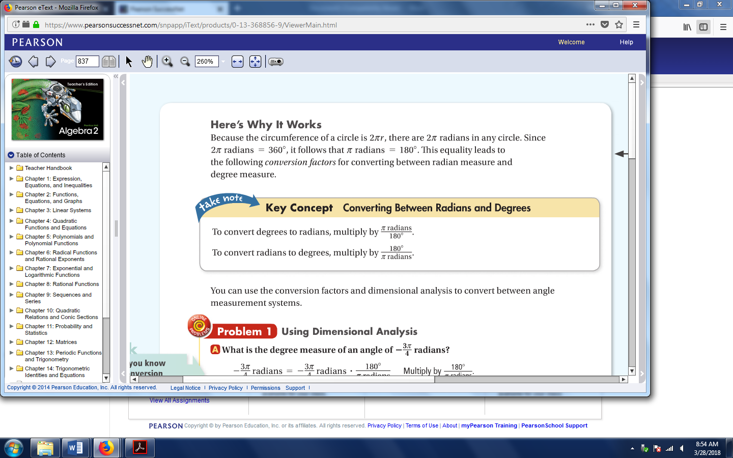

**Examples**

1. Convert radians to degrees.
$\frac{3π}{4}$

$\frac{π}{2}$

$\frac{5π}{6}$

2. Convert degrees to radians. Express your answer in terms of π and as a decimal rounded to the nearest hundredth.

a. 27 $°$

b. 225 $°$

c. -150 $°$

1. What are the exact values of the following?

a. cos $\frac{π}{4}$

b. sin $\frac{π}{4}$

c. cos $\frac{π}{2}$

d. sin $\frac{π}{3}$

**Practice 13-3: Complete your assignment on a separate sheet of paper. Show all work.**

1. Convert radians to degrees. Round to the nearest degree.

a. $\frac{7π}{6}$ b. $-\frac{π}{6}$ c. 1.8 radians

**2.** Write each measure in radians. Express your answer in terms of π and as a decimal rounded to the nearest hundredth.

a. -45 $°$ b. 120 $°$ c. 270 $°$

**13-8 Trigonometric Functions**

**State Standards**

**A2. F.LE.A.1** (formerly F-TF.A.1) Understand and use radian measure of an angle.

Understand radian measure of an angle as the length of the arc on the unit circle subtended by the angle. Use the unit circle to find sin θ, cos θ, and tan θ when θ is a commonly recognized angle between 0 and 2π.

**A2. F.LE.A.2** (formerly F-TF.A.2) Explain how the unit circle in the coordinate plane enables the extension of trigonometric functions to all real numbers, interpreted as radian measures of angles traversed counterclockwise around the unit circle.

**Objective**

The students will evaluate and graph reciprocal trigonometric functions.

**Key Concepts**

$$\left(cosine\right) cos θ=x \left(sine\right) sin θ=y (tangent) tan θ \frac{y}{x}$$

$$\left(secant\right) sec θ=\frac{1}{x} \left(cosecant\right) csc= \frac{1}{y} \left(cotangent\right) cot= \frac{x}{y}$$

**Examples**

1. Use the triangle to calculate the 6 trig functions.



1. Calculate the exact measures using the unit circle.

a. csc $\frac{π}{6}$

b. cot $\frac{-5π}{6}$

c. sec 3 $π$

1. Calculate the value. Round to the nearest thousandth.

a. sec 2

b. cot 10

c. csc 35 $°$

d. cot $\frac{π}{4}$

e. sin 150 $°$

f. cos 50 $°$

**Practice 13-8: Complete your assignment on a separate sheet of paper. Show all work.**

**Find each value without using the unit circle. If the expression is undefined, write *undefined****.*

**1.** csc (−*π*) **2. ** **3.** **4. **

**5. ** **6.** csc 3*π* **7. ** **8. **

**Use a calculator to find each value. Round your answers to the nearest thousandth.**

**9.** cot 42º **10.** csc  **11.** csc (–2) **12.** sec *π*